# Jenkins Basics

## Jenkins Overview:

It is open-source automation server that accelerates software deployment.

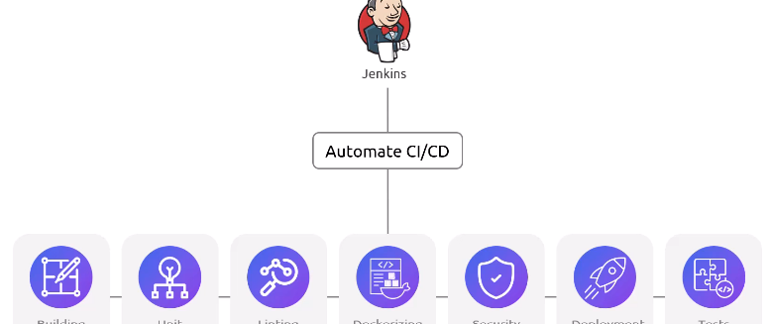

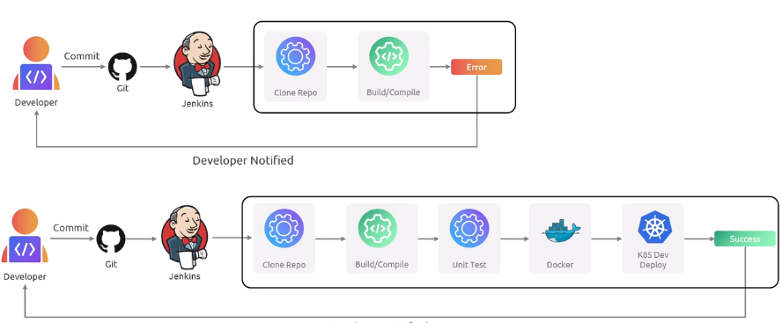

### Key Terms:

* Jobs: Jobs are building block of pipelines. Each job defines specific task like compiling code, running tests, deploying builds into specific environment.
* Builds: Each execution of a job with Jenkins maintaining a history for troubleshooting.
* Freestyle Project: Default project type offering flexible job definitions.
* Pipelines: Chain jobs together to automate tasks from development to deployment.
* Stages: Groups related jobs into phase like Build, Test, Deploy etc. for clarity.
* Nodes: Machines where Jenkins executes jobs with single controller or multiple agents.
* Plugins: Are extend Jenkins Functionality, Integrity, with various tools and technologies. This allows seamless integration with various tools and technologies used throughout development lifecycle.

### Pros:

* Open Source and Free
* Highly Customizable
* Scriptable For Advanced Users using Groovy
* Pipeline as code
* Mature and Feature Rich
* Scalable

### Cons:

* Complex to understand for new users.
* Frequent Updates so difficult to maintain Jenkins up to date.
* Being an open-source security is users’ responsibility.
* Before using we need to install and host it.

## Advantage of using SCM:

* Using SCM we can track every change in the code.
* It offers seamless collaboration between multiple developers.
* Changes can be reviewed and validated before merge.
* Conflicts can be resolved easily
* Sharing code is easy with use of SCM
* History can be tracked and if something goes wrong we can revert back to old version of code base.

## CICD Over View:

### Git Flow:

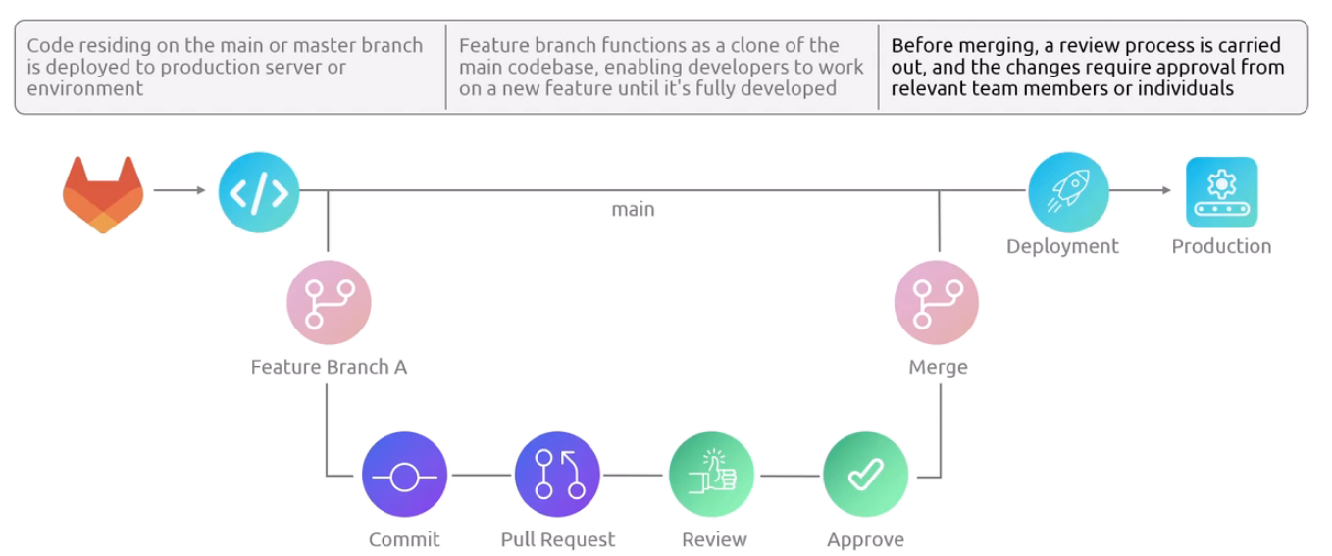

### Need of Continuous Integration:

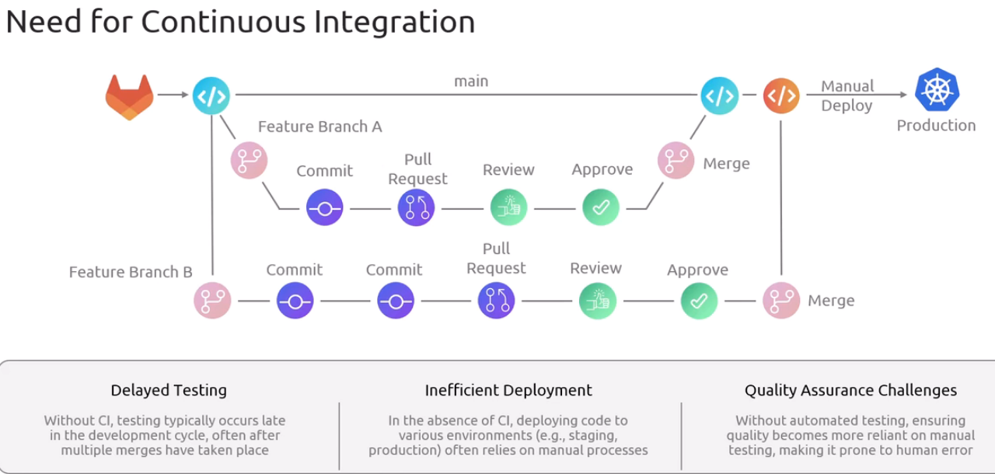

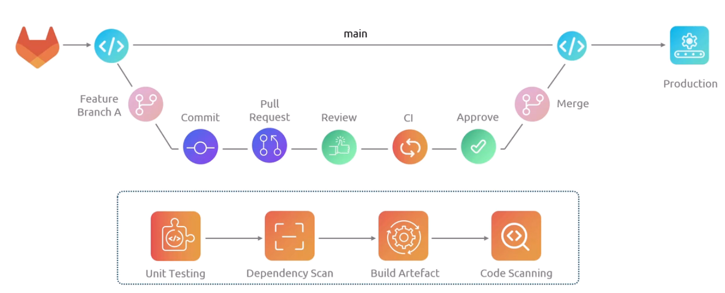

* With CI pipeline multiple developers from different branch can merge their code and integrates it smoothly.
* After CI code is to be deployed manually into production environment.
* But it is suggested to deploy it on preproduction before deploy it on production environment.

## Continuous integration and Continuous Delivery and deployment:

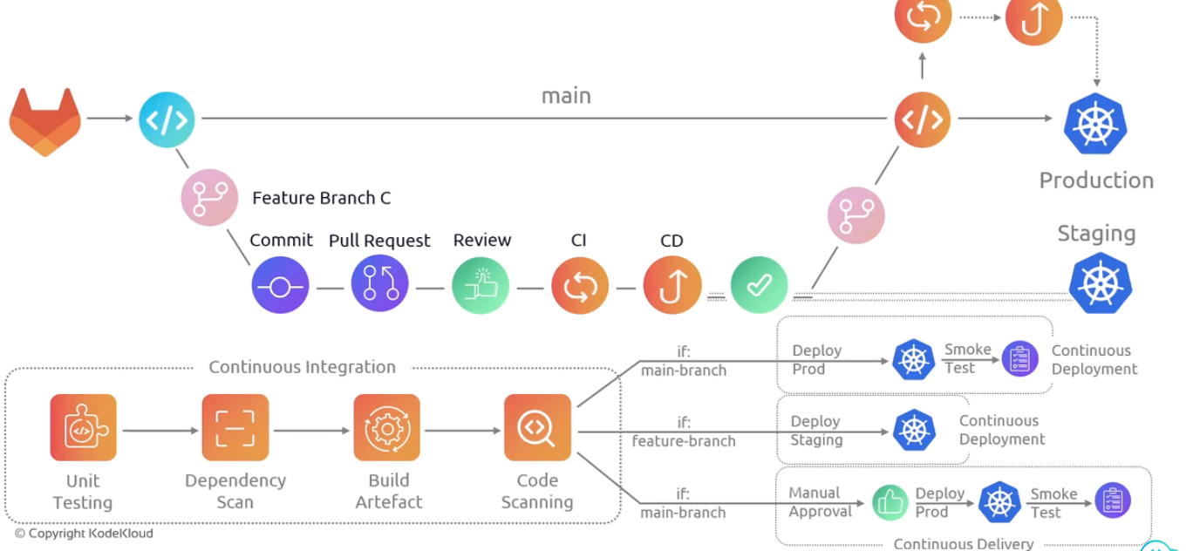

In some cases manual approvals are required before deploying changes in production environment to minimize risks, to ensure quality, to adhere compliance. It offer a safety by having manual assessment. This process of manual approval before deployment is called Continuous Delivery.

Git hub Repos used for references:

* <https://github.com/sidd-harth/jenkins-hello-world.git>
* <https://github.com/jenkins-kk-demo/parameterized-pipeline-job-init>

## Jenkins Architecture:

### Overview:

* Jenkins leverages distributed architecture to manage CICD pipelines efficiently.
* This structure allow scalability and power allowing to automate complex workflows across multiple machines.
* Components:
  + Controller or Master or Jenkins Server: Central Hub of Jenkins Set HUB managing all CICD processes centrally.

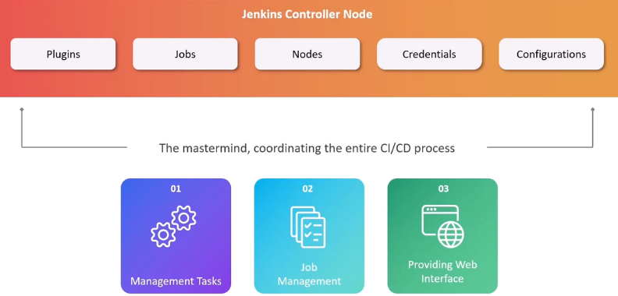

* For most of enterprise applications separate controller and worker nodes.
  + This arrangement boosts performance by distributing build tasks.
  + Prevents accidental damage.
  + Scalable for growth.

### Nodes:

* Jenkins workers are called nodes. They connect controller using SSH or JNLP (Java Network Launch Protocol).
* Each node has executer which are slots for running build jobs concurrently. It is a thread for execution of task.
* More than one executors allow for parallel job which will help to speed up build processes.
* The number of executers assigned to a node is determined on basis of available resources on node such as CPU, Memory etc.
* Ideally one executer is allocated to one node.

### Agents:

* Agents acts as an extension of Jenkins managing the task execution by using executers on remote node.
* An agent is a node that connects to a controller. It defines the communication protocol and the authentication mechanism used.
* Any tools required for build or test processors are installed on agents.
* We can use docker containers having image of necessary tools and software for build jobs.
* We can use kubernetes cluster with pods as build agent. This allows on demand scaling and efficient resource utilization.

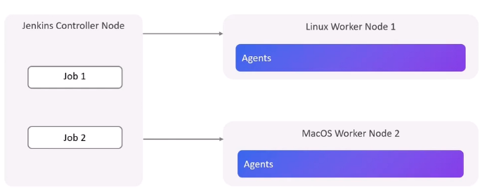

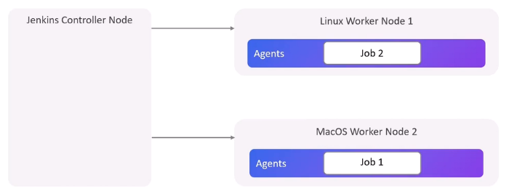

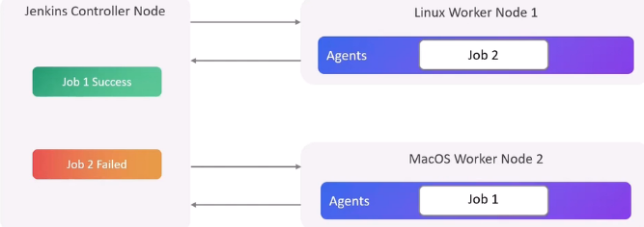

* Controller allocates jobs to agents and agents updates the status of jobs to controller.

## Jenkins Installation:

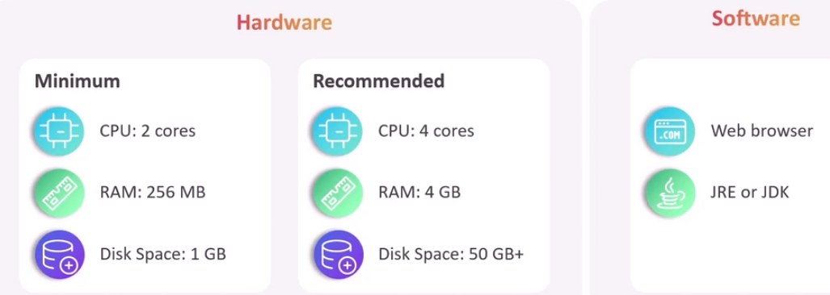

* Jenkins required java packages to be installed.
* Jenkins can be installed using .war file or using packages.
* If Jenkins is installed using .war file then Jenkins home location i.e. Jenkins_home is inside home directory of user.
* If Jenkins is installed using packages then its home directory is /var/lib/jenkins. This directory has all other data related to Jenkins.
* We can alter location by exporting environment variable JENKINS_HOME and its value to desired path.
* After installation jenkin requires initial set up password available in logs.

journalctl -u jenkins

Same password is stored in file /var/lib/jenkins/secrets/initialAdminPassword

* Use node ip address and port 8080 to access jenkins GUI.
* After accessing required install plugins or use Install suggested plugin.

### Jenkins User Interface:

* After entering credentials user can access GUI of Jenkins.
* Manage Jenkins is option used to alter configuration based on requirement.
* Inside Mange Jenkins there is option of System. Configure desired system settings such as no. of executers etc.
* You can get system information using System Information option.
* Logs can be viewed using System Log option.

### Type of Projects Available in Jenkins:

* Freestyle Project: Allows to define custom build steps and configurations for simple and unique projects. Limitations are:



* Pipeline Project: Uses specific code to define the entire build pipeline. It includes stages, steps and conditions for complex build processes and continuous delivery workflows.
* Multibranch Pipelines: Builds upon Pipeline Projects and allowing you to manage build from multiple branched of single code repository. It is useful in projects that involves frequent branching and development activities.
* Maven Projects: Streamlined building projects that uses Maven a popular build automation tool for java projects. It detects and executes Maven commands based on projects pom.xml file.
* Multi-configuration Project: allows you to run the same build process with different configurations. You can define various combinations of parameters and run tests or build for each combination.
* Organization Folders: Used to organize Jenkins project into a hierarchical structure for better project management.

## Jenkins Plugins:

* Plugins enhance the potential of Jenkins.
* Jenkins is a powerful tool only if required plugins are installed and used.
* Plugins are extensions that supercharge Jenkins with functionalities for various tools and technologies you use in your development process.

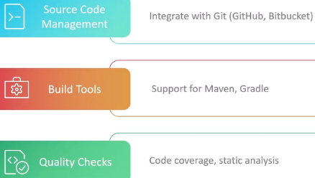

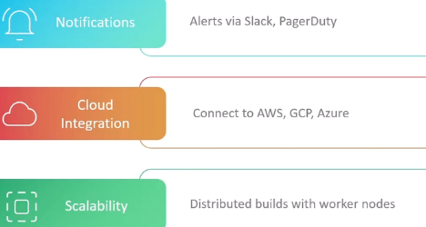

* Jenkins plugins are jar files with two type of extensions .hpi (Hudson plugin) or .jpi (Jenkins plugin).

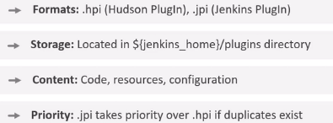

# Jenkins Administration

## What is CICD and why CICD needed?

* CICD is way to package a code and deploy it in system that could be VM or server less function like AWS Lambda.
* CICD is used to increase the speed of software delivery without compromising on the reliability.

### How to test the code?

* Since coding is collaborative work so when we integrate the code we should test it.

### Workflow and integration:

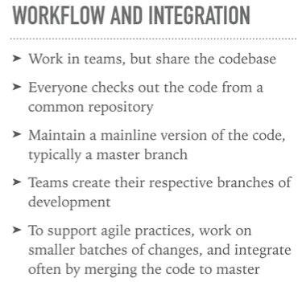

### What is tested?

* Block of code that is integrated is tested using unit tests.
* Build should not break that means compilation of code should not fail.
* Integration tests from main line to back ends.
* Static analysis is performed using tools such as sonarcube to test whether our code has some vulnerabilities, bugs or malpractices and suggest improvements.
* Code is tested with realistic load using Load test.
* Acceptance test, compliance test.
* And all these test should be a part of pipeline.



* All these tests are performed continuously.
* So continuous integration is process of ensuring that every change that get integrated to the main line of the repository goes through enough checks that we are confident about its reliability.

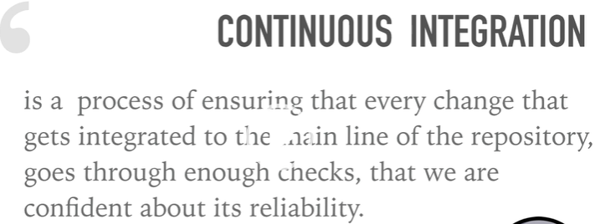

Simple testing can achieve higher reliability by reducing most of its defects.

### Desired features of CI tool:

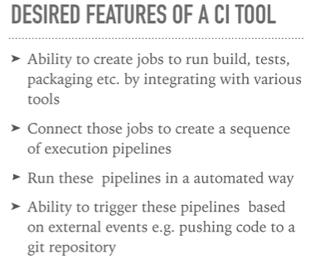

* Any of following tools is used for CICD in organizations:

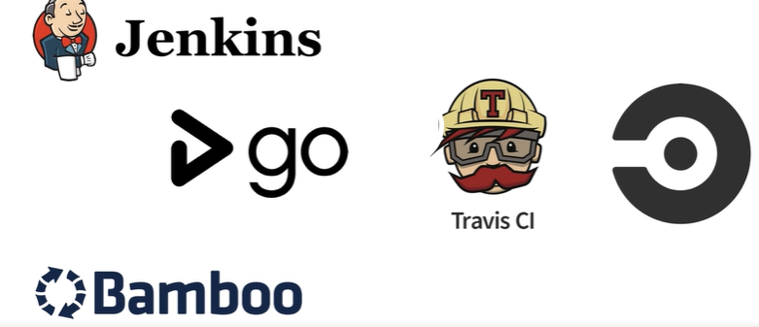

* Jenkins is most prominently used tool.

### CI involves following activities:

#### Packaging of code:

* Suppose your code available on git hub repository in different folders and directories.
* CI process will clone your repo and package your code.

#### Testing of code:

* In CI process code is tested.
* It will run unit test, integration test etc automatically.

## Continuous deployment:

* CD is extension of CI where code is deployed to dev and staging environment to get confidence about deploying code to production environment.
* Once code is successfully deployed and worked finally in staging environment it so deployed in production environment.

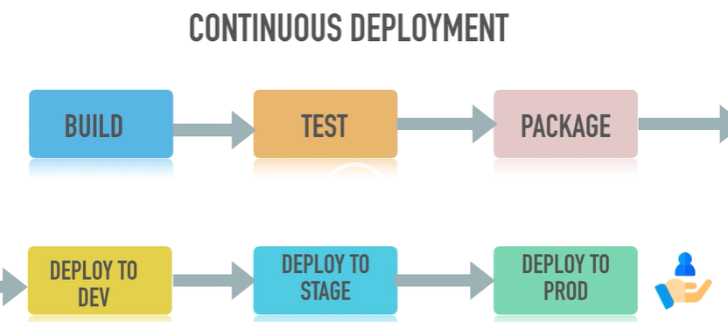

## Continuous delivery:

* It has same flow as continuous deployment inly change is that before placing code to production environment we have to get necessary approval from release manager.
* 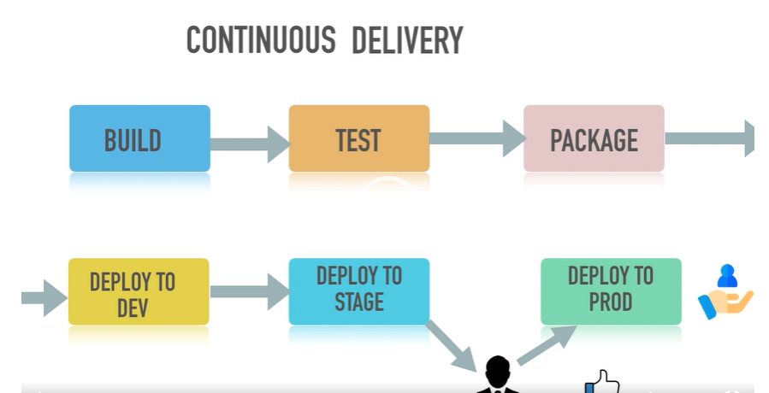

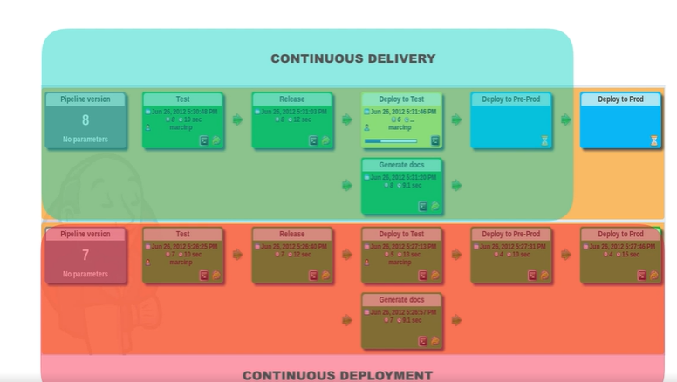

* Continuous delivery is controlled and safer way.

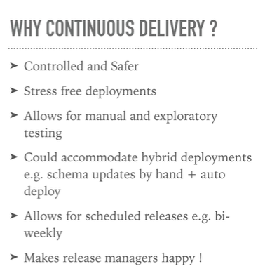

## Principles of CICD:

* Woking in smaller batches and delivering it faster is fundamental requirement. This can be implemented with agile practices.
* Build should automated but also quick.
* Test should be automated.
* Deployment should be automated.

## Practices of CICD:

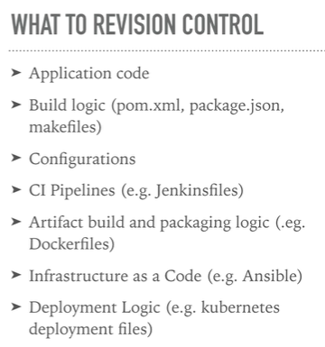

* Setting or development workflow.

E.g. trunk based workflow.

* Code review practices helps to improve quality of code. Code is reviewed by one of senior Coolidge.
* To achieve all this we implements automated CI pipelines and most preferable tool is Jenkin.

## Path to achieve continuous delivery:

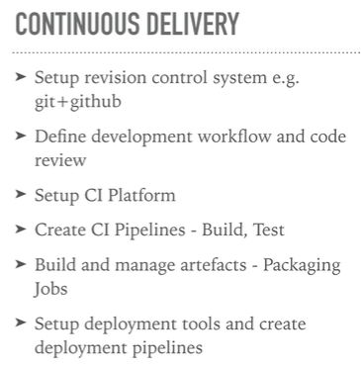

## CI/CD with docker:

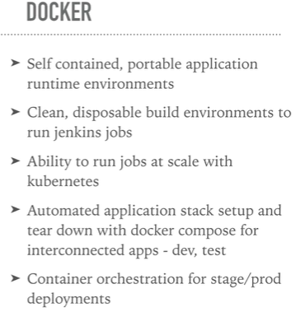

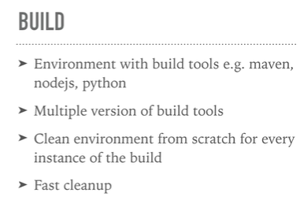

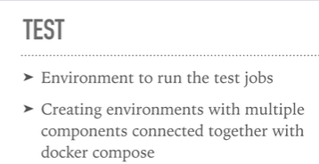

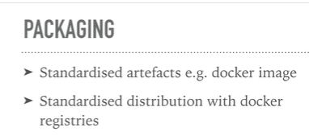

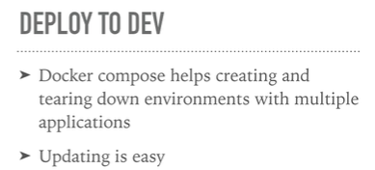

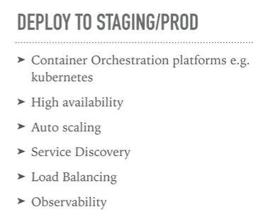

## Installing Jenkins:

Jenkins can be installed on VMs or can be run as docker container.

## First Way To Create Jenkins environment using container:

### Instructions to install Jenkins on Ubuntu VM:

* sudo apt update -y
* To install Jenkins java is prerequisite.

sudo apt install openjdk-11-jdk

* Add repository key to system

wget -q -o -- <https://pkg.jenkins.io/debian-stable>

### Command to find port used by the Jenkins SSH server, let us begin interacting with Jenkins over ssh with the user:

curl -Lv http://localhost:8085/login 2>&1 | grep -i 'x-ssh-endpoint'

ssh -i /home/mike/.ssh/jenkins_key -l mike -p 8022 jenkins-server help

## Second Way To Create Jenkins environment using container:

* Create VM with user Jenkins and user id should be 1000.
* Install Docker.
* Create directory at /home/jenkins/jenkins-data/jenkins_home

**mkdir -p /home/jenkins/jenkins-data/jenkins_home**

* Create docker compose yaml file with following contents in jenkins-data directory.

**touch docker-compose.yaml**

* **services:**

**jenkins:**

**container_name: jenkins**

**image: jenkins/jenkins**

**privileged: true**

**user: jenkins**

**ports:**

**- "8080:8080"**

**networks:**

**- net**

**volumes:**

**- "/home/jenkins/jenkins-data/jenkins_home:/var/jenkins_home"**

**volumes:**

**jenkins_home:**

**networks:**

**net:**

* **sudo docker compose up -d**

### In order to execute job on remote machines:

* Create another container base OS as centsos or Ubuntu.
* Configure ssh service to access it.

**Steps:**

* Create another directory centos in Jenkins-data directory.

**mkdir -p /home/Jenkins/Jenkins-data/centos**

**cd /home/Jenkins/Jenkins-data/centos**

* Create ssh key.

**ssh-keygen -f remote-key**

* Create Dockerfile with following contents

**FROM centos**

**RUN cd /etc/yum.repos.d/ && \**

**sed -i 's/mirrorlist/#mirrorlist/g' /etc/yum.repos.d/CentOS-* && \**

**sed -i 's|#baseurl=http://mirror.centos.org|baseurl=http://vault.centos.org|g' /etc/yum.repos.d/CentOS-* && \**

**yum update -y**

**RUN yum install -y openssh-server**

**RUN useradd remote_user && \**

**echo "remote_user:1234" | chpasswd && \**

**mkdir /home/remote_user/.ssh && \**

**chmod 700 /home/remote_user/.ssh**

**COPY remote-key.pub /home/remote_user/.ssh/authorized_keys**

**RUN chown remote_user:remote_user -R /home/remote_user/.ssh && \**

**chmod 600 /home/remote_user/.ssh/authorized_keys**

**RUN ssh-keygen -A**

**RUN rm /run/nologin**

**CMD /usr/sbin/sshd -D**

Create the image.

**docker build image -t remote-server .**

* **Modify Docker compose file.**

services:

jenkins:

container_name: jenkins

image: jenkins/jenkins

privileged: true

user: jenkins

ports:

- "8080:8080"

networks:

- net

volumes:

- "/home/jenkins/jenkins-data/jenkins_home:/var/jenkins_home"

remote_host:

container_name: remote-host

image: remote-host

build:

context: /home/jenkins/jenkins-data/centos

networks:

- net

volumes:

jenkins_home:

networks:

net:

* Create Containers using:

**Docker compose up -d**

* Login to Jenkins UI and Install ssh plugin.
* Configure credentials.
* Configure remote server with above credentials.
* Build free style job with parameters and in build steps use option of execute shell script on remote host using ssh.

## Jenkins Plugins and integration:

* Plugins are the primary means of enhancing the functionality of a Jenkins environment to suit organization or user specific needs.
* Plugins allows you to connect to other services.
* If user wants to connect AWS then user should download AWS plugin, configure it in jenkins and AWS plugin facilitate Jenkins to connect AWS.
* Plugins facilitate Jenkins to interact with respective entity, perform desired actions.

E.g using github plugin which is another type of CICD tool used for deployment then we can use built in Jenkins and deploy those build to github actions using github plugin.

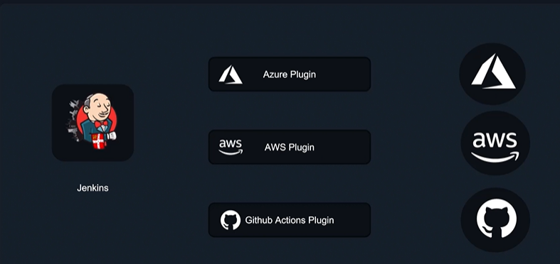

* We can add remove, mange plugin from manage option available on Jenkins dashboard.

### To enable Jenkins-cli we need to authenticate user. This is performed by adding Jenkins api token to client machine:

Genrate the token from following options.

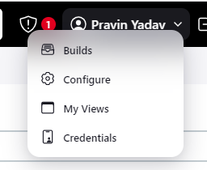

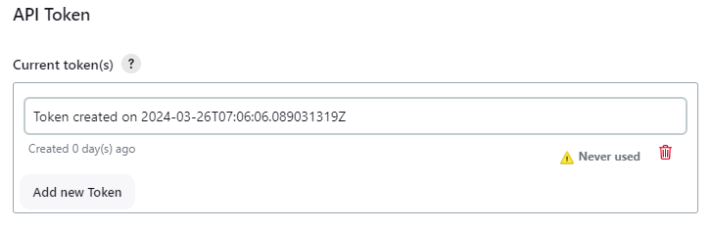

### Procedure to use Jenkins cli:

#### Download the jar file:

wget http://<jenkins_server_Ip>:<jenkin_server_port>/jnlpJars/jenkins-cli.jar

#### Copy token using following command:

java -jar jenkins-cli.jar -s http://<Server_Ip>:<Server_Port>/ -auth <User_Id>:<Token> -webSocket <Command>

E.g.

java -jar jenkins-cli.jar -s http://3.110.166.57:8080/ -auth pravins31:117a0d4c6e3e958a9f9cd2284aac6dfc63 -webSocket list-jobs

#### Command to restart Jenkins frim Jenkins cli:

java -jar jenkins-cli.jar -s http://localhost:8085 -auth 'admin:Adm!n321' restart

#### We can perform any command using jenkins cli as fillows.

java -jar jenkins-cli.jar -s http://localhost:8085 -auth '<User_Name>:<password>' <Commad>

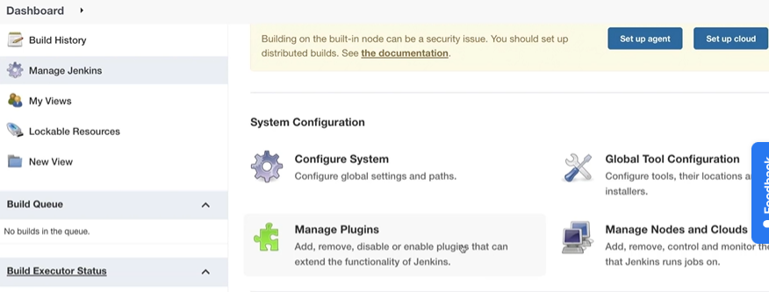

### Various options in Jenkins:

As a Jenkin user he must be aware of following objectives about Jenkin.

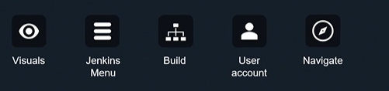

* Using New Item option we can create new object such as pipeline, free style project etc.

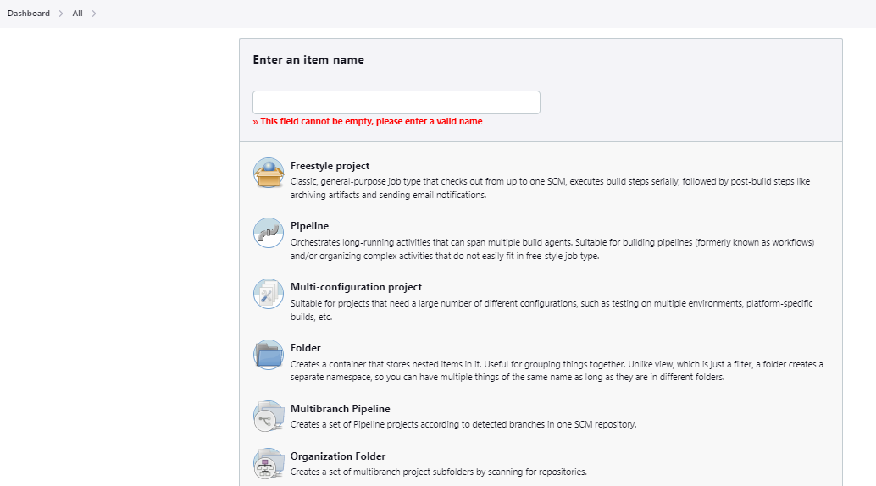

* We can navigate to various user account from People option.

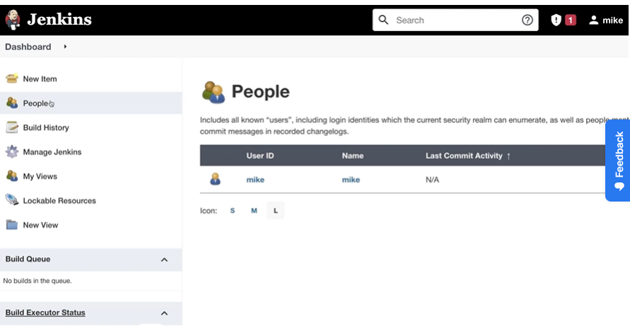

* After clicking on particular user it will display various options for builds of user, views, credentials, configurations etc.

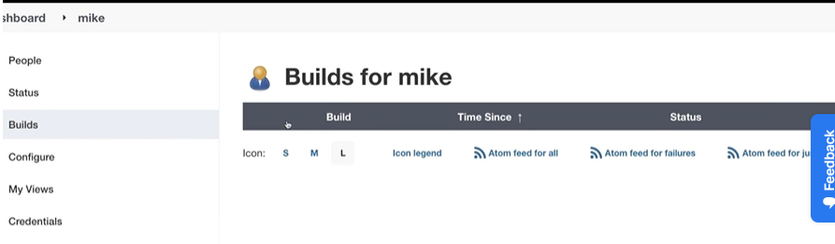

* Build history will show CICD history.

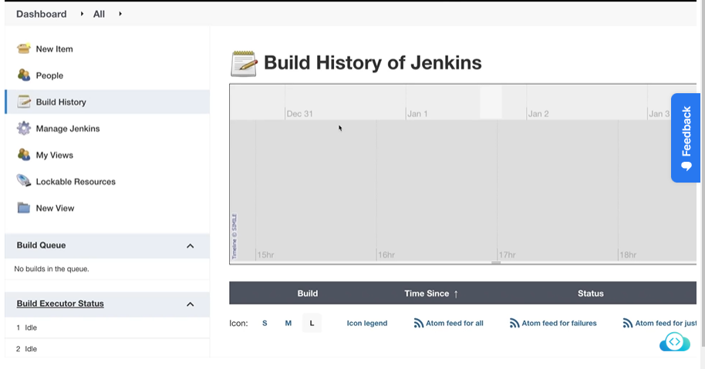

* Mange Jenkins options display number of other options such as system configuration, security, status information, troubleshooting tolls and actions etc.

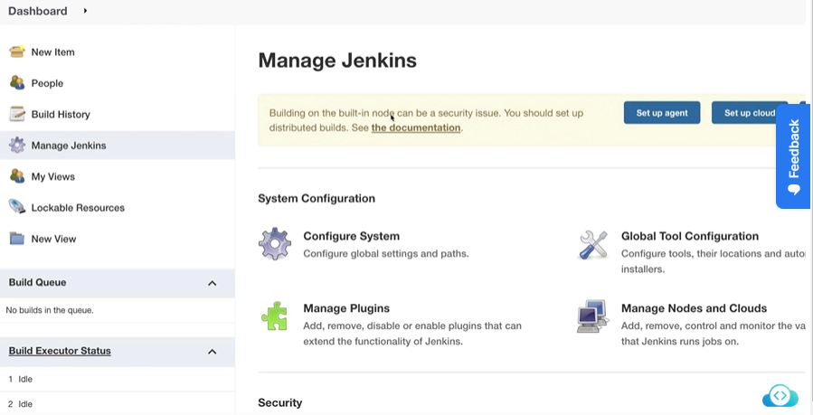

* With New view option one can create your own little view.
* View can be created as a simple list format or my view option displays all options to which user currently has access to.

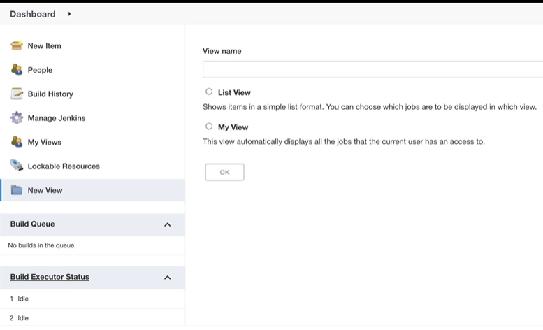

### Managing users and teams:

* To work in a team on Jenkin project someone has to manage users or teams.
* To do this there are various option in manage Jenkins/security option such as global security, configure credential providers, manage credential, manage users etc.

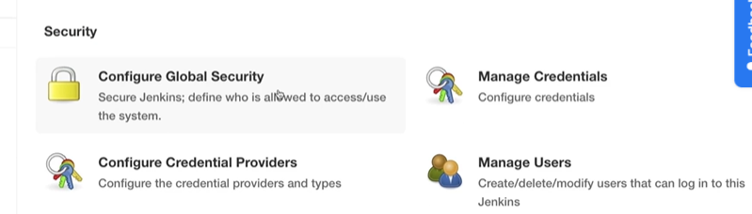

* With Manage Users option we can create new user. After creating user we have configuration setting for that particular user.
* Rolle based authorization strategy is implemented using plugin with same name.
* After installing this plugin we can manage roles using manage and assign roles option.

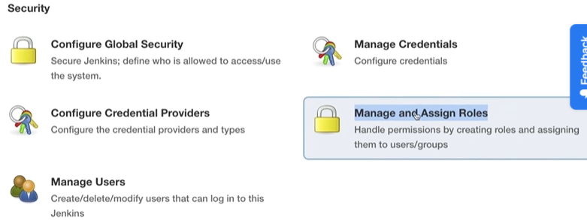

* We can add new role using manage role option.

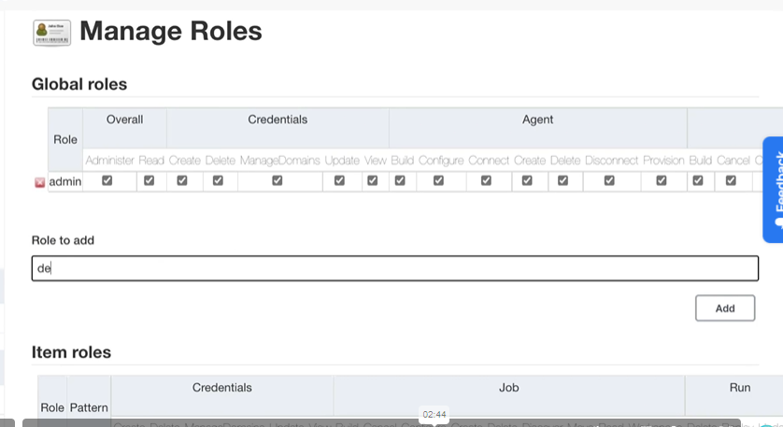

* We can assign roles to user using assign role option.

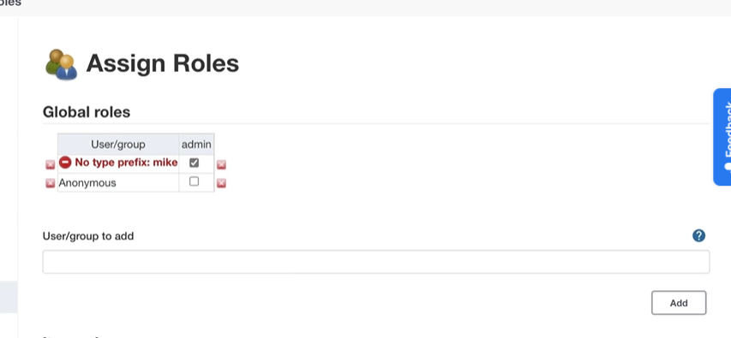

### Managing System Credentials:

* Parameters configured under Global configuration decides who can have access to what and who can manage what.
* It will display options and other info like system directory path (/var/lib/Jenkins), system message, no of executors, labels, usage, etc.
* All global configuration parameters of Jenkins are available under global configuration of configure system setting.

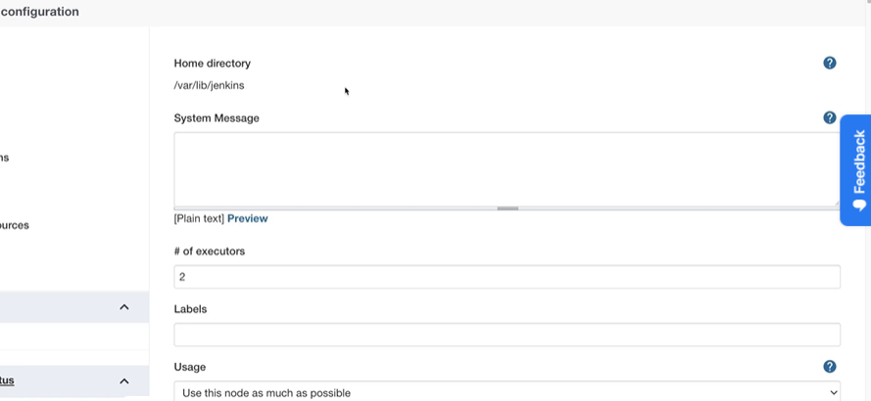

### Configure Global Security:

* It has parameter called Security Realm which has no of options such as delegate to servlet containers, Jenkins’ own user database, LADP, unix users, Group database, None.

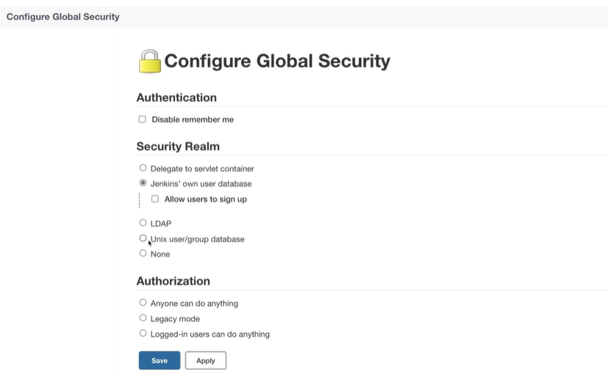

* We have authorization strategy options available here. Additional information about option is provided when we put cursor on question mark symbol shown.

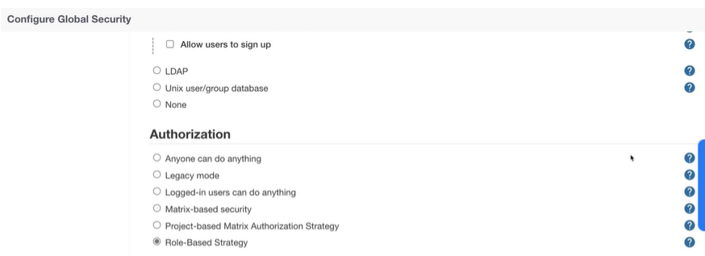

* Agents options is disabled by default. It is used to communicate to external agents over particular or random port. But With random port it is difficult to manage firewall rules.

### CICD and build visuals:

* Dashboard will show builds as follows.

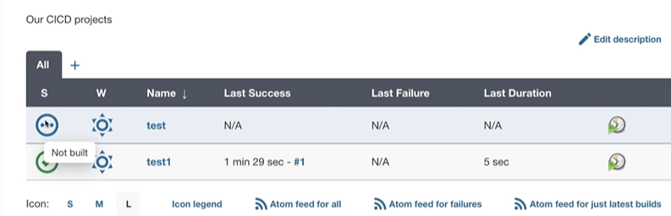

* When you click on any of available builds it will display many options as shown.

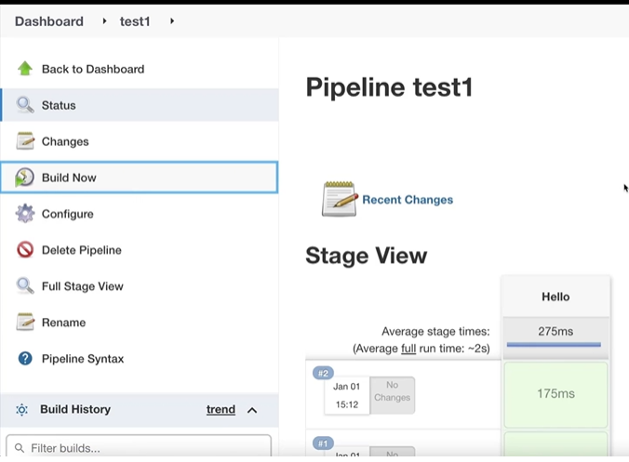

## Administration of Jenkins involves following major activities:

### Backup and Restoring Jenkins:

#### There are two type of backups:

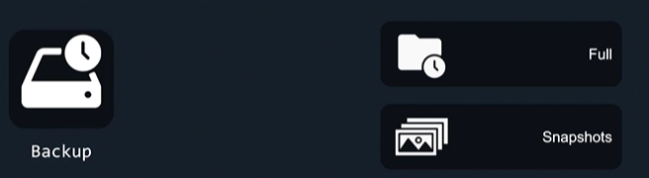

#### Folders to be backed up:

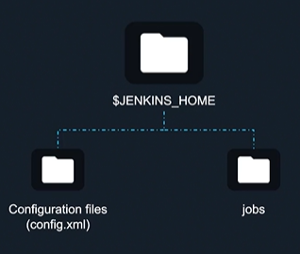

#### Procedure for Jenkin backup:

There are three ways of Jenkins Backup:

##### **Filesystem Snapshot:**

* Not Recommended as a long term solutions

##### **Writing a shell script that backup Jenkins Instance:**

* write a shell script that back up Jenkin instance. Script is available at following Github repository.

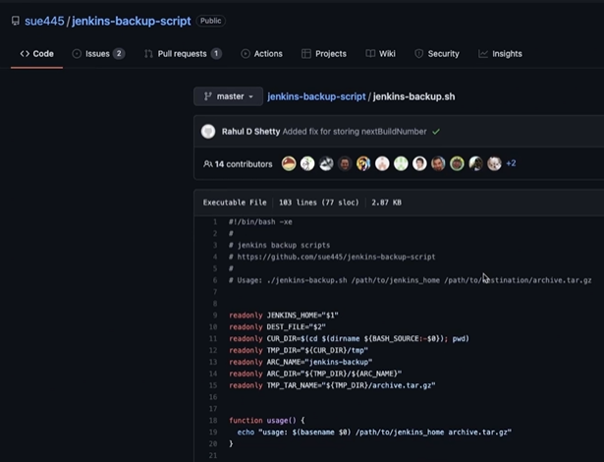

##### Plugins For backup:

* Requires ability to install and extend functionalities of Jenkins.
* There are plugins like Backup, ThinBackup (widely used) etc.
* Install the Thin Backup plugin

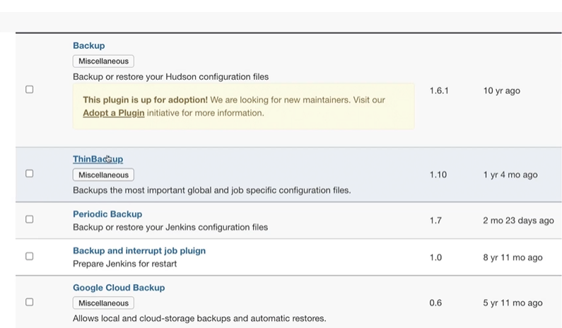

* ThinBack up will display following options.

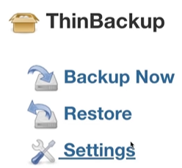

* In settings option enter the backup directory details, and select folders to be backed up.
* Give proper permissions to backup directory.

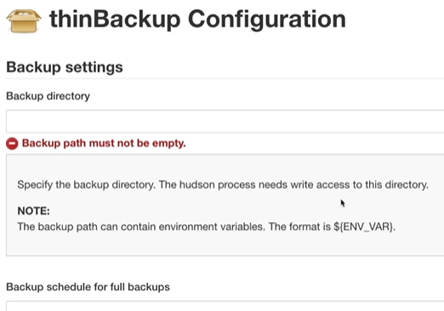

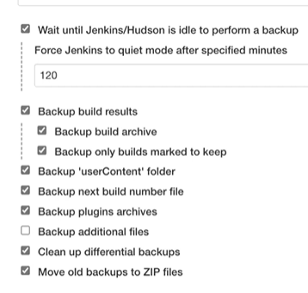

* Click on Backup option it will save backup files at defined directory.

##### Restore Jenkins Backup:

* Click on restore option of ThinBackup.
* Select the file from which backup to be restored.
* Click on Restore

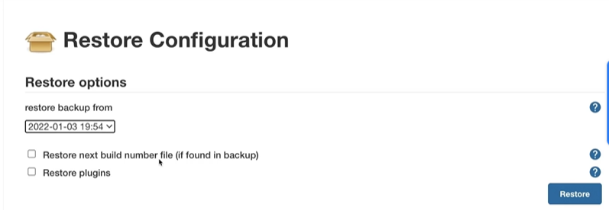

### Monitoring Jenkins:

* There various options used for monitoring Jenkins using datadog, Prometheus, dynatrace etc. We need to install plugin of desired option.
* Prometheus and Grafana is used for monitoring.
* Install the Prometheus plugin. After installation of plugin Jenkins server metrics are gathered at <Ip_address_Jenkins_server:Jenkins_server_port>/prometheus

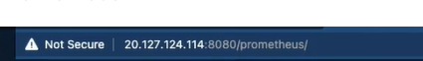

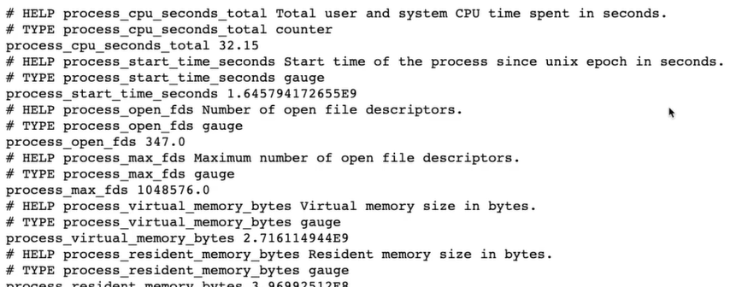

* To integrate Prometheus server
  + Jenkin prometheus plugin expose endpoint default/prometheus as environment variable.
  + You need to have Prometheus server. Where you need give Jenkins server path as a target at /etc/prometheus/prometheus.yaml as follows.



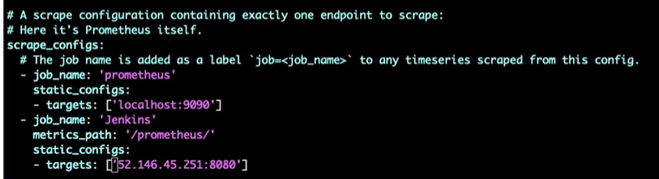

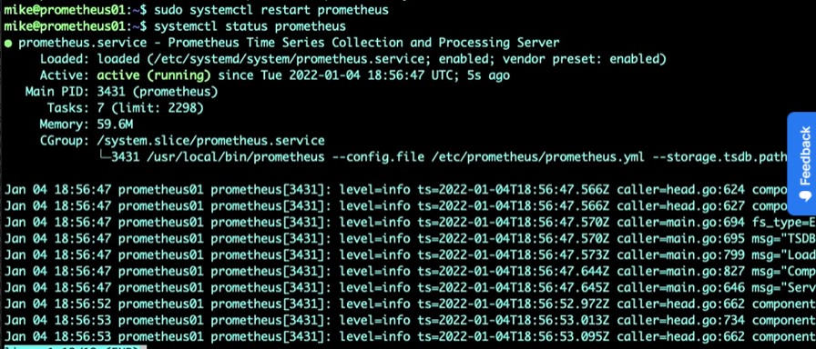

* You will find Jenkins server as target of Prometheus server.

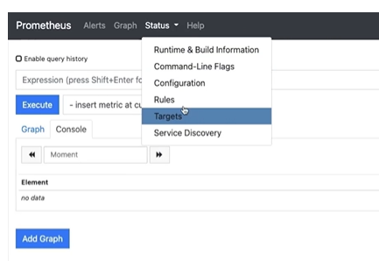

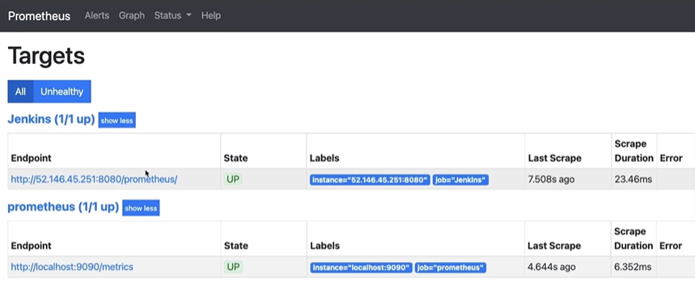

* Prometheus plugin from Jenkins inject data at /prometheus directory in format that can be read by Prometheus server.
* Prometheus server has <Jenknis_server_ip_address>/Prometheus endpoint as a target. Using this path prometheus sever gets required data.
* Various type of data options that can be read and displayed by Prometheus server from Jenkins data is available here.

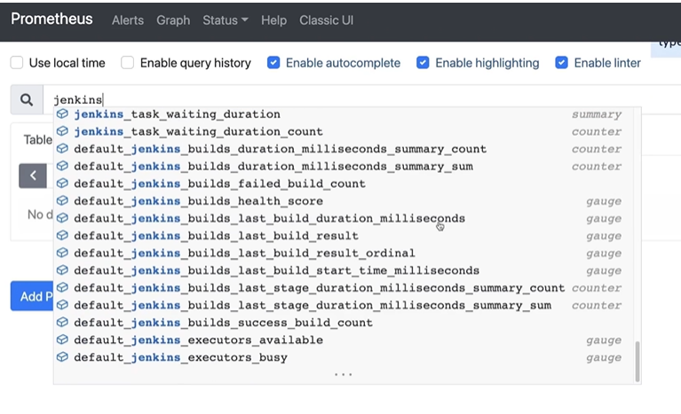

* Select the parameter to be read and click on execute.

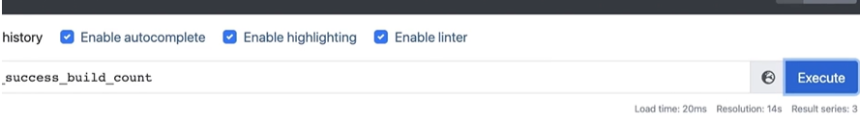

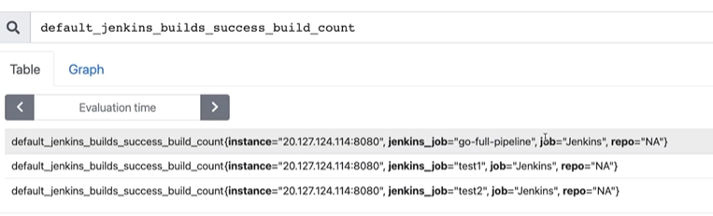To add Prometheus datasource in Grafana.

* Login into Grafana and click on Add your first datasource.

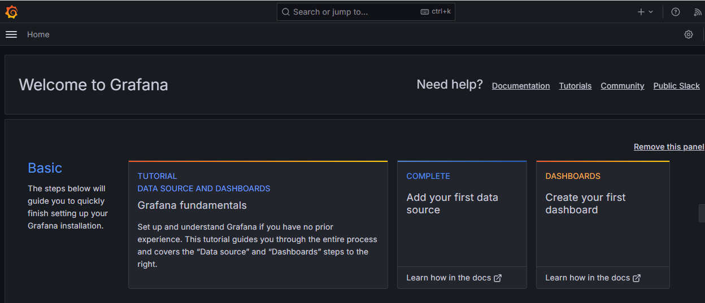

* Then select Prometheus and enter http://localhost:9090 in the URL box.

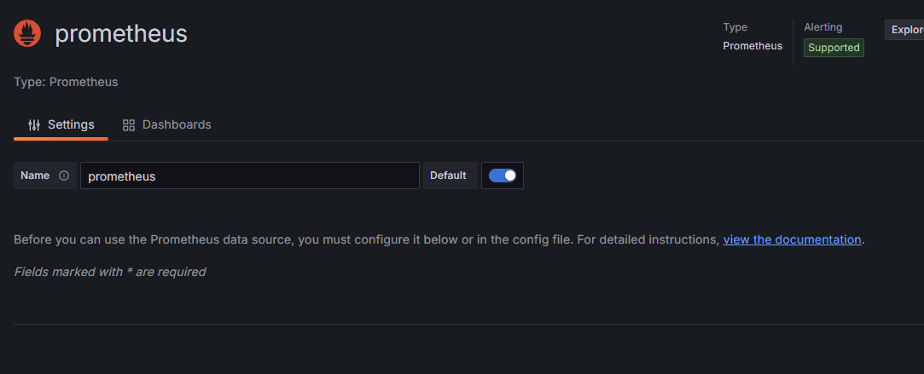

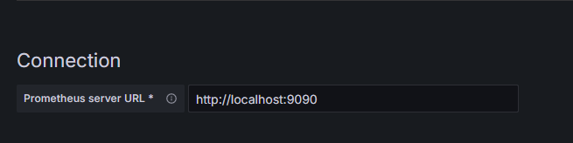

* Finally click on Save and test button at the bottom.
* Click on Grafana logo, move back to the dashboard and click on Create your first dashboard.
* Click on add visualization.

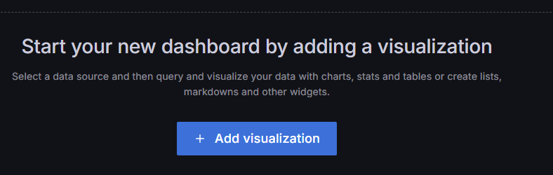

* Select Prometheus data source.

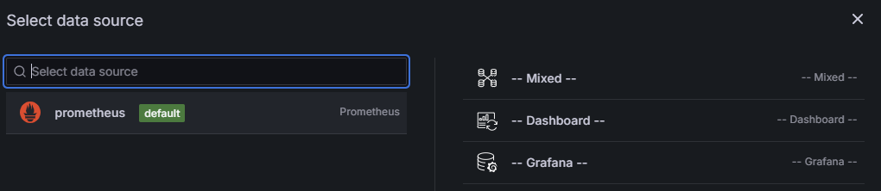

* At the bottom enter jenkins_job_count_value in the Metrics browser.

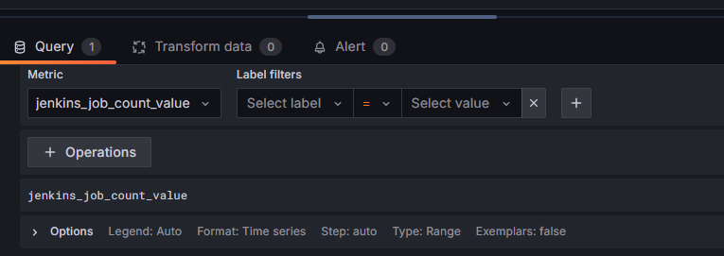

* On the right side under Panel options, enter Jenkins Jobs Count in Title. Click on Apply button on the top right corner.

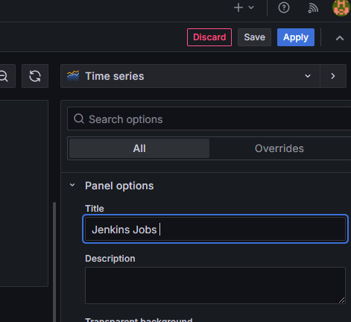

* Finally click on the Save dashboard button (second button on the top right).
* Enter dashboard name as Jenkins and save it.

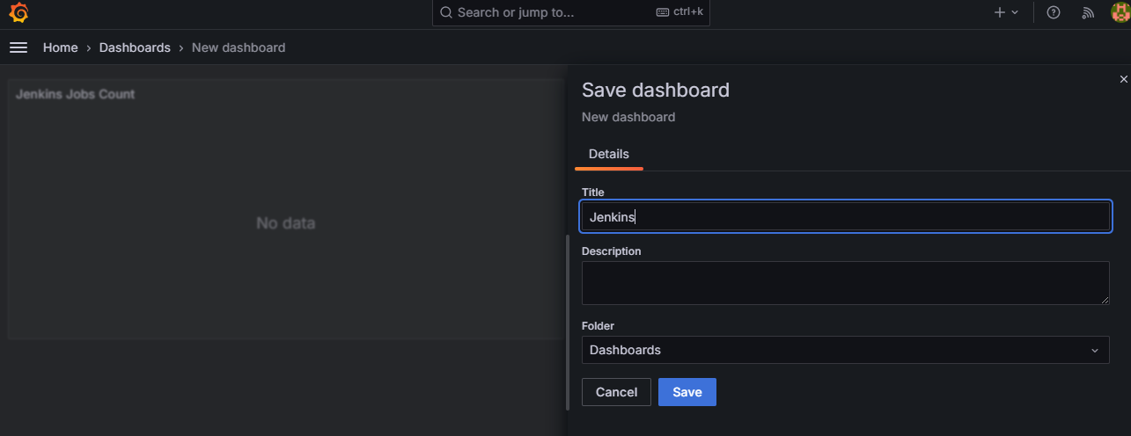

## Pipelines:

A Jenkins file is text file that contains definitions or instructions that tells pipeline what it should do and to do that what plugins and services it should use.

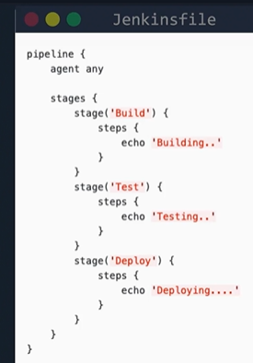

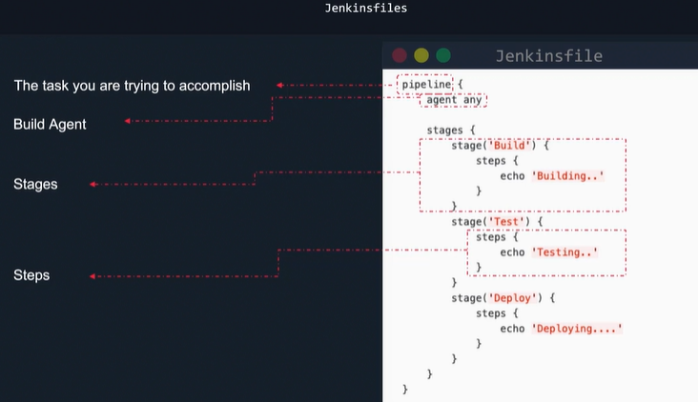

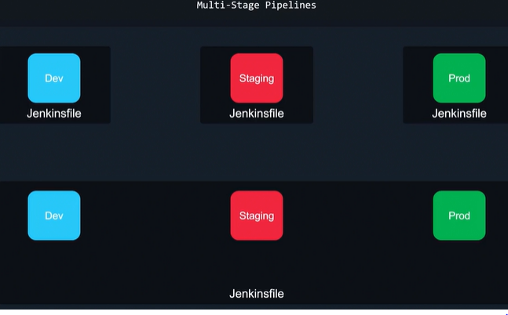

### Build a Jenkins file

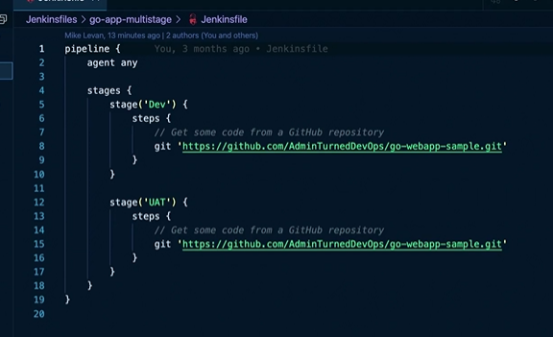

* Multistage pipeline has multiple stages inside defined with keyword stages and has pair brackets inside which actual stages are defined with keyword stage.
* Each stage has unique name and has pair of brackets inside which steps are defined.
* Each stage has multiple steps to be performed.

### Process to create Pipeline:

* Click on new item.

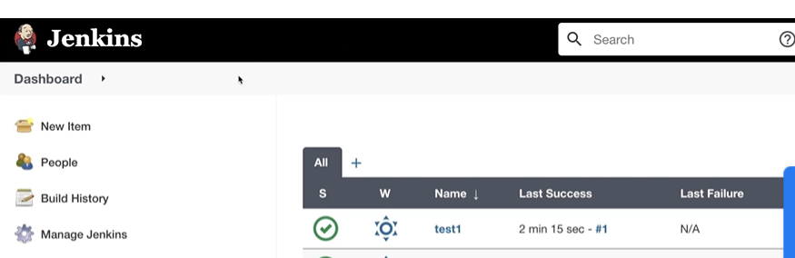

* Enter the name and select the type of project (There are multiple options available). In our case we need to select pipeline.

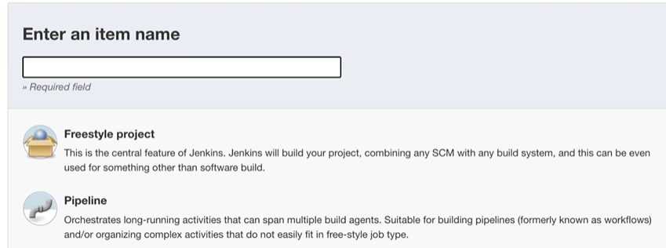

* Various options for build are available.

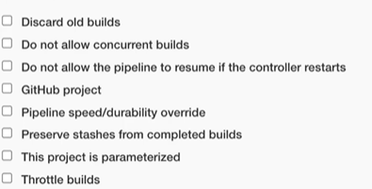

* We need to select build triggers if required.

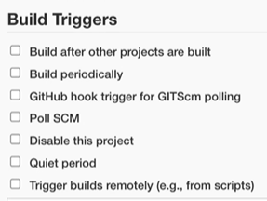

* We have to copy Jenkins code or script in pipeline section.

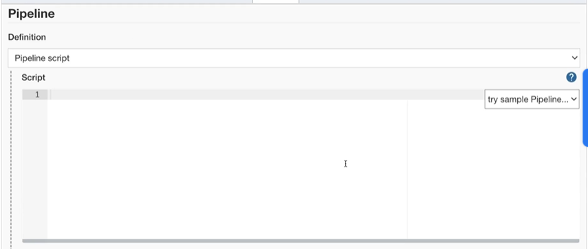

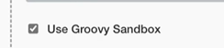

* Click on save and use option Build Now to initiate build.

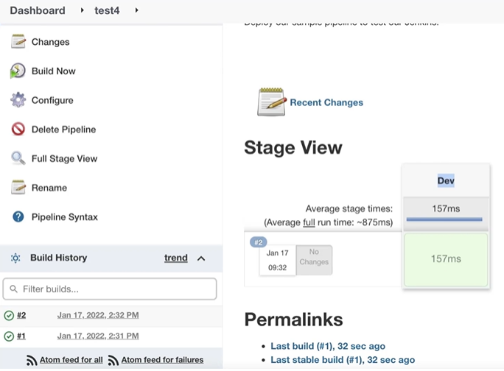

* Multistage pipeline has multiple stages instead of single stage.

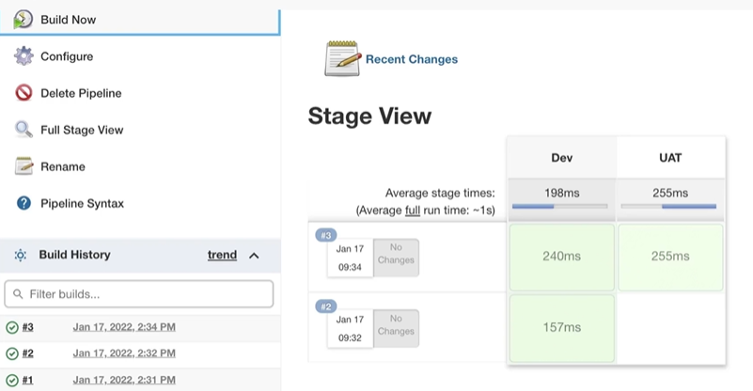

### CI pipeline:

* We need to add plugin of desired software based on type of code which we have to build and test like go, python etc. in our case it is go.

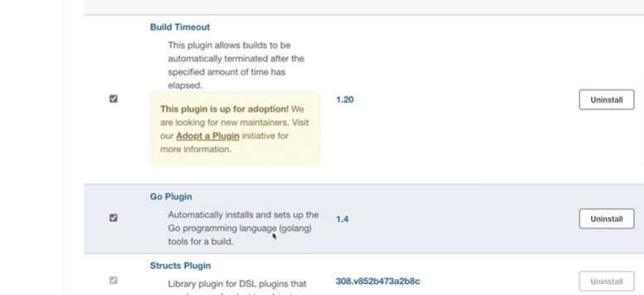

* Add this in tools section of Jenkins file.

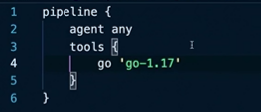

* Set up the environment.

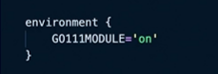

* Add the test stage to Jenkins file.

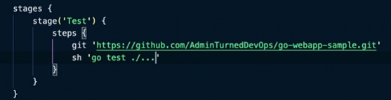

* Final Jenkins file will be as follows.

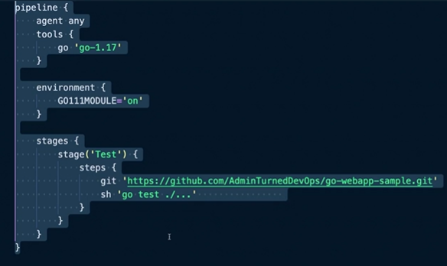

### Building CD pipeline:

* In CICD fill pipeline we need to get the code from github, build the code and prepare image of respective build and deploy it in cluster.
* We are going to deploy code over docker. We need all docker plugins.
* We need to ensure docker is installed on build server.

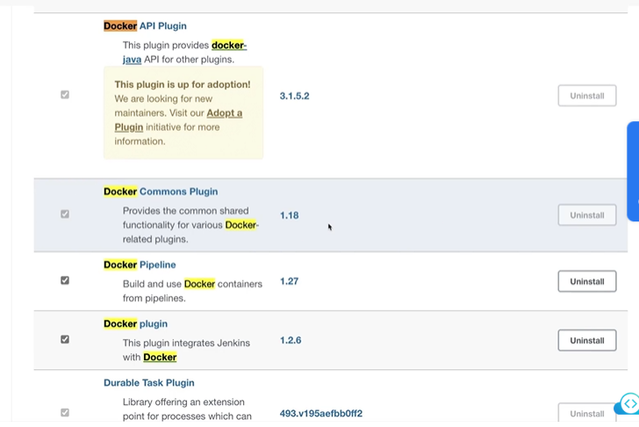

* Add build stage to pipeline as follows.

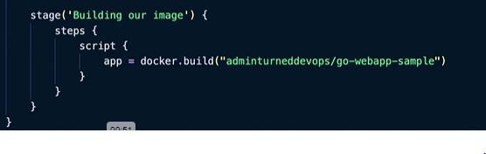

pipeline {

agent {

label {

label 'master'

customWorkspace "${JENKINS_HOME}/${BUILD_NUMBER}/"

}

}

environment {

Go111MODULE='on'

}

stages {

stage('Test') {

steps {

git 'https://github.com/kodekloudhub/go-webapp-sample.git'

}

}

stage('build') {

steps {

script{

image = docker.build("adminturneddevops/go-webapp-sample")

sh "docker run -p 8090:8000 -d adminturneddevops/go-webapp-sample"

}

}

}

}

}

* This will build the docker image.

### Full pipeline deployment:

* Modify the build stage and add new stage called run as follows.
* Shell command in build stage will prepare the build and place it at path /var/lib/jenkins/workspace/<Pipeline_Name>.

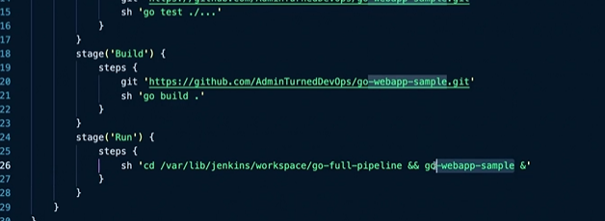

* Application is build and deployed using full pipeline as above.

## Build Agents:

* Build agents are systems that run entire workloads. They are the system that runs processes that are configured in pipeline.
* Build agents are used to run pipeline.

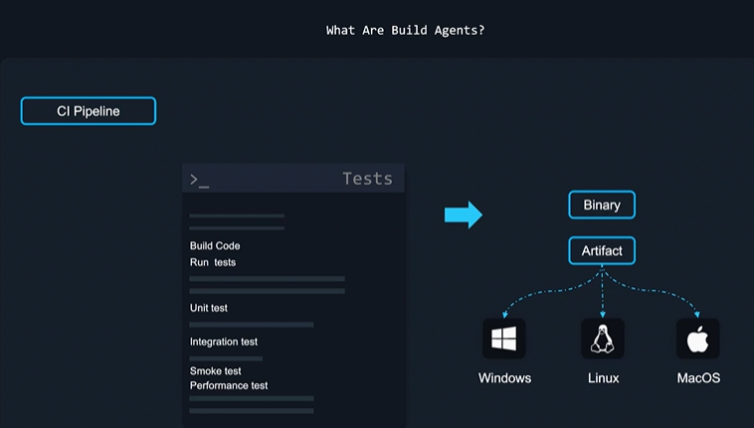

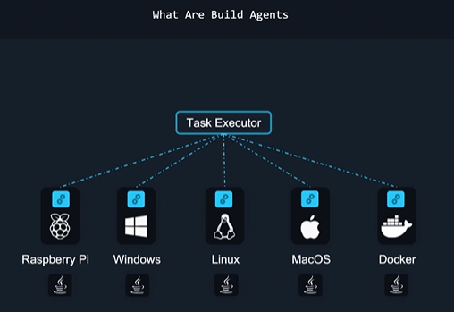

* Build agent can be anything

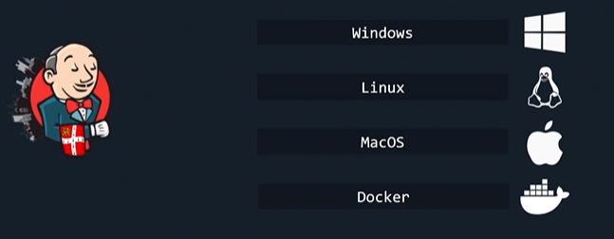

* It is recommended to keep Jenkins server and Build agent separate.

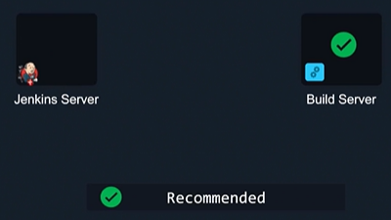

### Ubuntu Server As Build Agent:

* Add sudo user on build server.



* Assign sudo privileges to new user.



* Check groups of newuser



* Add credentials of new user created in Jenkins server.

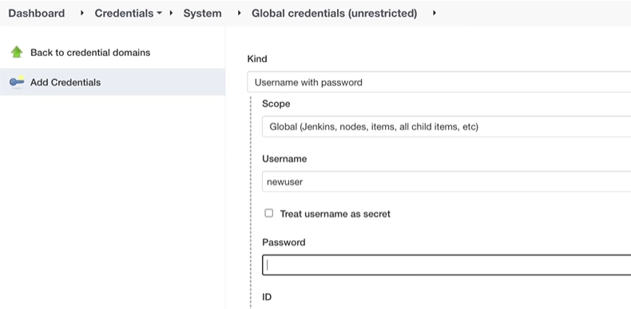

* Add new agent with proper required details

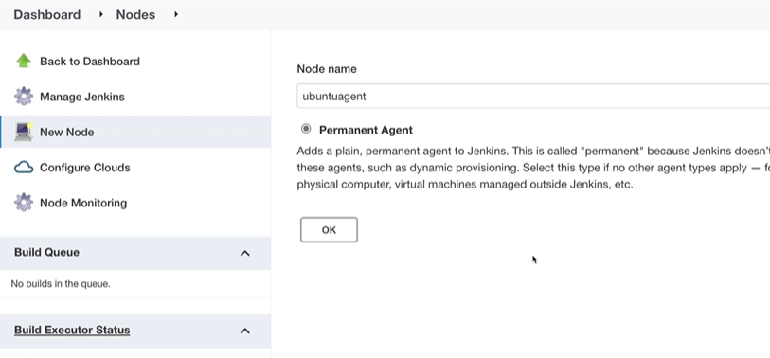

## 

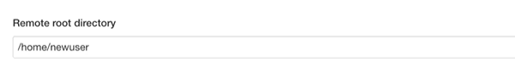

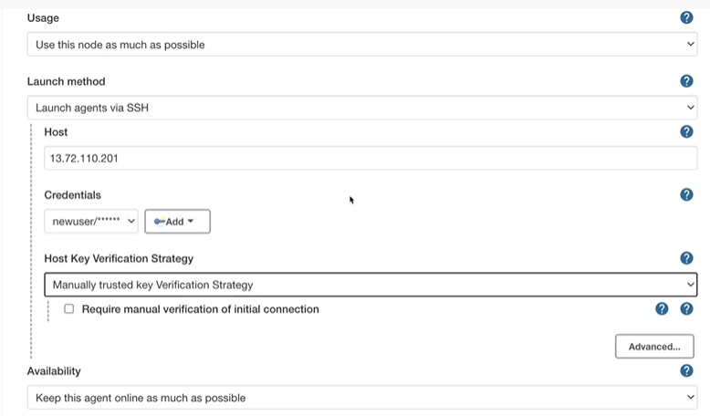

### Using New Build Agent:

* Create freestyle project.

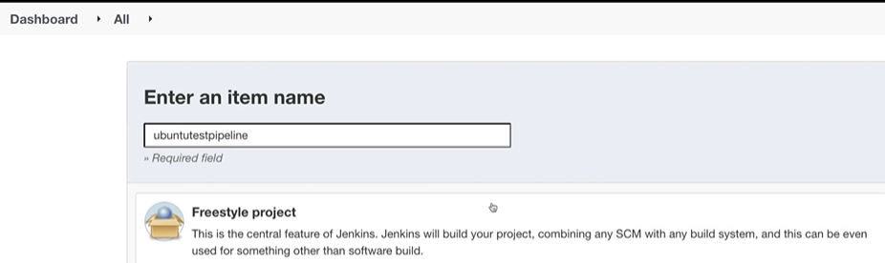

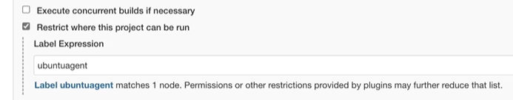

* Add the steps to job and save to execute.
* In case of pipeline script, we mention agent using labels.

### Docker container as build agent:

* We can use build container and execute during stages of pipeline during pipeline execution itself.
* We can add instructions within a pipeline script to create container and execute pipeline instructions in it as follows.

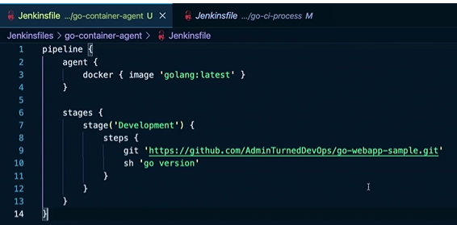

## Blue Ocean:

* User experience of using GUI is enhanced in blue ocean.
* Visualization of execution of is very much improved in blue ocean.

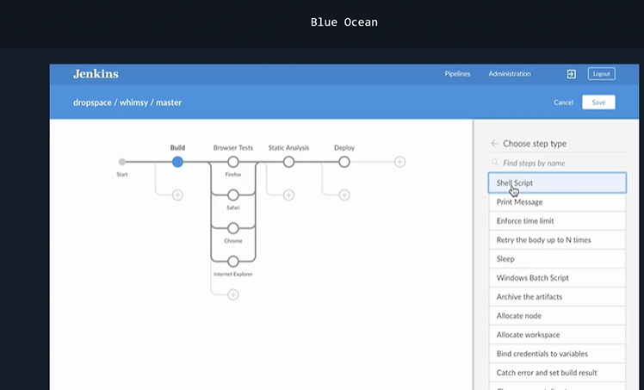

* Blue ocean features:

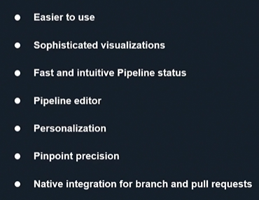

* Blue ocean is installed using plugin in Jenkins.

## Security In Jenkins:

* In Jenkins we have to secure code and server both.

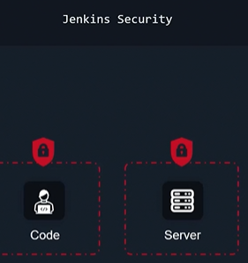

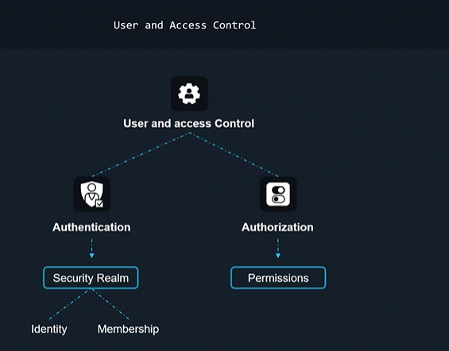

### Common Security mistakes:

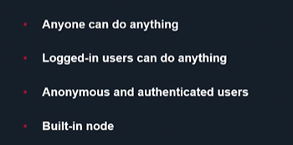

### Managing and enable security in Jenkins:

* Various plugins such as role-based access strategy, metrics authorization is used to get additional security features.

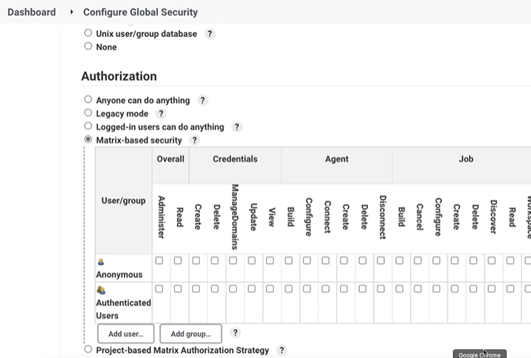

## Pipeline syntax in detail:

### Jenkins has two type of syntax:

* Scripted Syntax:
* Declarative Syntax:

How to push Docker Image to DockerHUB:

* Create Access Token To DockerHub Repo.

## PipeLine Scripting Syntax:

### Types of Pipeline code:

* Scripted pipeline: Starts with keyword node and code is written in script formats
* Declarative pipelines: Starts with keyword pipeline and code is written in declarative formats.
* Declarative pipeline has following major sections (PATS3P):

P(pipeline): pipeline code is under this directive

A(agent): it may be node like controller, slave or container where pipeline script is executed

T(tools):

S3:

stages: all required stages of job build are defined here.

stage(<stage_name>): Required stages of pipeline build is defined here with desired name od stage. At least one stage directive should be defined under stages directive.

steps: Steps to be executed for job build is defined here. AT least one steps directive should be there under each stage directive.

P(post): Post actions(action after job build is finished) that is to be executed can be defined under this directive.

* All conditional commands defined inside script directive.
* Batch commands used inside steps directive starts with keyword bat.
* shell commands used inside steps directive starts with keyword sh
* To avoid writing bat or sh for each command we can write bat or sh and then start and end the section with """.
* single line comment marked with //
* multiline comments starts with /*, ends with */

### Variable:

* In built variables: In build variable are system defined variable of Jenkins. Ids used for in built variables can be listed using <Jenkins_url>:<Jenkins_port>/env-vars.html. e.g BUILD_NUMBER. To get value of variable we use prefix $ with variable name e.g. $ BUILD_NUMBER
* User defined variables: User can define required variables using keyword environment at global and stage level.

These variables can be defined at three levels.

* + At global level or Under pipeline directive: variables have scope span across all stages
  + At stage level or Under stage directive: variables have scope span across particular stage
  + At script level or under script directive located below steps directive: variables have scope span across particular step.
  + Precedence of variables if same variable name use at all levels: Script level > Stage Level > Global Level.
  + If name variable is used for script and any of other two levels then we can access variable value of stage or global level inside script directive by using syntax ${env.<variable_name>}
  + Like python + symbol used as concatenation of strings in Jenkins. But concatenation operation can be performed only inside script directive.

### Parameters:

* Parameters are interactive variables and used to pass values dynamically to builds.
* String: Used to pass single text string.

E.g. string(name: 'DEPLOY_ENV', defaultValue: 'staging', description: '')

* Text: used to pass multiple text lines as an input. Parameter, which can contain multiple lines.

E.g. text(name: 'DEPLOY_TEXT', defaultValue: 'One\nTwo\nThree\n', description: '')

* Choice: Used to pass or assign any one of value from given choices to parameter.

E.g. choice(name: 'STAGE', choices: "Build\nTest\nDeploy", description: "Select any of given choices")

* booleanParam: It has to values true or false. If selected value of parameter assumed as true if default value is mentioned as true.

E.g. booleanParam(name: 'SONAR', defaultValue: 'true', description: 'Toogle to bypass build')

* Password: It is used to pass or assign password to given parameter.

E.g. password(name: 'PASSWORD', defaultValue: 'SECRET', description: 'A secret password')

* File: If user wants to upload certain file which is used for building a job then file parameter is used. But In order to use file parameters in Jenkins pipeline code we need to install fileparameter plugin. This plugin provides two options.
  + Base64 file parameter
  + Stashed file parameter

Note: Every normal parameterized build first time fails as it do not enable parameters. We can run this fist build with dry run option so that failed first build will not be displayed in history.

stage('Parameterizing'){

steps{

script{

if("${params.dryrun}" == "Yes"){

currentBuild.result='ABORTED'

error('Dry RUN COMPLETED. JOB PARAMETERIZED.')

}

}

}

}

### Options section:

1. buildDiscarder: Persist artifacts and console output for the specific number of recent Pipeline runs.

E.g. options { buildDiscarder(logRotator(numToKeepStr: '1')) }

1. checkoutToSubdirectory: Perform the automatic source control checkout in a subdirectory of the workspace.

E.g. options { checkoutToSubdirectory('foo') }

1. disableConcurrentBuilds: Disallow concurrent executions of the Pipeline. Can be useful for preventing simultaneous accesses to shared resources, etc.

E.g options { disableConcurrentBuilds() } to queue a build when there’s already an executing build of the Pipeline, or options { disableConcurrentBuilds(abortPrevious: true) } to abort the running one and start the new build.

1. disableResume: Do not allow the pipeline to resume if the controller restarts.

E.g. options { disableResume() }

1. newContainerPerStage: Used with docker or dockerfile top-level agent. When specified, each stage will run in a new container instance on the same node, rather than all stages running in the same container instance.
2. overrideIndexTriggers: Allows overriding default treatment of branch indexing triggers. If branch indexing triggers are disabled at the multibranch or organization label, options { overrideIndexTriggers(true) } will enable them for this job only. Otherwise, options { overrideIndexTriggers(false) } will disable branch indexing triggers for this job only.
3. preserveStashes: Preserve stashes from completed builds, for use with stage restarting.

E.g. options { preserveStashes() } to preserve the stashes from the most recent completed build, or options { preserveStashes(buildCount: 5) } to preserve the stashes from the five most recent completed builds.

1. quietPeriod: Set the quiet period, in seconds, for the Pipeline, overriding the global default. E.g.options { quietPeriod(30) }
2. retry: On failure, retry the entire Pipeline the specified number of times.

E.g. options { retry(3) }

1. skipDefaultCheckout: Skip checking out code from source control by default in the agent directive.

E.g. options { skipDefaultCheckout() }

1. skipStagesAfterUnstable: Skip stages once the build status has gone to UNSTABLE.

E.g. options { skipStagesAfterUnstable() }

1. timeout: Set a timeout period for the Pipeline run, after which Jenkins should abort the Pipeline.

E.g. options { timeout(time: 1, unit: 'HOURS') }

1. timestamps: Prepend all console output generated by the Pipeline run with the time at which the line was emitted.

E.g. options { timestamps() }

1. parallelsAlwaysFailFast: Set failfast true for all subsequent parallel stages in the pipeline. E.g. options { parallelsAlwaysFailFast() }
2. disableRestartFromStage: Completely disable option "Restart From Stage" visible in classic Jenkins UI and Blue Ocean as well.

E.g. options { disableRestartFromStage() }. This option can’t be used inside of the stage.

### stage options:

The options directive for a stage is similar to the options directive at the root of the Pipeline. However, the stage-level options can only contain steps like retry, timeout, or timestamps, or Declarative options that are relevant to a stage, like skipDefaultCheckout.

Inside a stage, the steps in the options directive are invoked before entering the agent or checking any when conditions.

#### Available Stage Options:

1. skipDefaultCheckout: Skip checking out code from source control by default in the agent directive.

E.g. options { skipDefaultCheckout() }

1. timeout: Set a timeout period for this stage, after which Jenkins should abort the stage.

E.g. options { timeout(time: 1, unit: 'HOURS') }

1. retry: On failure, retry this stage the specified number of times.

E.g. options { retry(3) }

1. timestamps: Prepend all console output generated during this stage with the time at which the line was emitted.

E.g. options { timestamps() }

### Trigger Build:

* Triger some other job from current build: build function used to trigger some other job from current build. Syntax is as follows:

build('<JoB_Name_To_Be_triggered> ') or build '<JoB_Name_To_Be_triggered> '

Sample Script:

pipeline{

agent any

stages{

stage('trigger_test'){

steps{

build(job: 'test1', propagate: false )

build 'test2'

}

}

}

}

* Suppose two job are trigger to build from current job but first job is failed second job is not triggered due to default behavior of pipeline. This behavior is altered using propogate property in build function as follows.

**Sample Script:**

pipeline{

agent any

stages{

stage('trigger_test'){

steps{

build(job: 'test1', propagate: false )

build 'test2'

}

}

}

}

* If first job is failed still second job is successful then current job status is successful. But this is not desired result. To reflect the status as per requirement one can use following code. We can change the result of current build by assigning desired value to currentBuild.result.

**Sample script:**

pipeline{

agent any

stages{

stage('trigger_test'){

steps{

script{

jobresult= build(job: 'test1', propagate: false ).result

build 'test2'

if( jobresult == 'FAILURE'){

currentBuild.result='UNSTABLE'

}

}

}

}

}

}

* We can pass parameters to downstream triggered job from upstream. To do this we define parameters to be passed inside build function of upstream job as follows.

**Upstream Job Script:**

pipeline{

agent any

stages{

stage('upstream'){

steps{

script{

jobresult= build(job: 'test1', propagate: false,

parameters: [

string(name: 'msg', value: "Hi"),

string(name: 'buildnumber', value: "$BUILD_NUMBER")

]).result

if( jobresult == 'FAILURE'){

currentBuild.result='UNSTABLE'

}

}

}

}

}

}

**Downstream test1 Job Script:**

pipeline{

agent any

parameters{

string(name: 'msg', defaultValue: "Hello")

string(name: 'buildnumber', defaultValue: "3")

}

stages{

stage('downstream'){

steps{

echo "MSG: $msg"

echo "Downstream Build number is: $BUILD_NUMBER"

echo "UPstream Build number is: $buildnumber"

}

}

}

}

### Schedule Jobs:

#### Cron Schedule:

We use cron function inside triggers directive to scheudele job as per requirement.

**Sample Script:**

pipeline{

agent any

triggers{

cron('H/2 * * * *')

}

stages{

stage('upstream'){

steps{

script{

jobresult= build(job: 'test1', propagate: false,

parameters: [

string(name: 'msg', value: "Hi"),

string(name: 'buildnumber', value: "$BUILD_NUMBER")

]).result

if( jobresult == 'FAILURE'){

currentBuild.result='UNSTABLE'

}

}

}

}

}

}

#### pollSCM Schedule:

Jenkins Job itself will check the changes in got repository and trigger job to build if any changes identified. We need to configure schedule to check changes in git repository inside triggers directive. We need to provide git repo URL to job inside steps directive.

### Parallel Jobs:

* Computer systems are capable to execute parallel jobs (Generally equal to number of core of processor) but Jenkins jobs are executed sequentially. To execute jobs those are independent at a time we use parallel directive in Jenkins as follows.

**Sample Code:**

pipeline{

agent any

stages{

stage('Parllel_jobs'){

failFast true

parallel{

stage('EXE_JOBA'){

steps{

build('test1')

}

}

stage('EXE_JOBB'){

steps{

build('test2')

}

}

}

}

}

}

* We can define only single steps directive inside any stage. But we have requirement that multiple steps directive to be defined inside any single stage and that should be executed parallel then we should use parallel directive, inside parallel directive we should add required stage directives with their NAMES and we should define steps directive inside each stage directive. Replace build instructions with required instruction in above sample code.
* **Failfast:** If we one desired that the parallel job build is failed then immediately rest of parallel jobs build process should fail and stop. This is achieved with failfast instruction above parallel directive inside stage directive.

### post actions:

These are executed on completion of Pipelines stages section generally has instructions to send notifications etc.

#### Various blocks available in post section:

* **always:** Runs instruction inside this block will be executed in all scenarios whatever is the result of build.
* **changed:** executed when status of current build is deferred compared to previous build.
* **fixed:** executed when status of current build is success and previous build is failed.
* **regression:** executed when status of current build is failed, aborted or unstable and previous build is successful.
* **aborted:** executed when status of current build is aborted
* **failure:** executed when status of current build is failed
* **success:** executed when status of current build is success.
* **unstable:** executed when status of current build is unstable.
* **cleanup:** execute for each build in the last after execution of all post sections.

**Note: User can define post section at end of each stage instead of end of stages directive.**

* **Sample Code:**

pipeline{

agent any

stages{

stage('Parllel_jobs'){

failFast true

parallel{

stage('EXE_JOBA'){

steps{

build('test1')

}

}

stage('EXE_JOBB'){

steps{

build('test2')

}

}

}

}

}

post{

always{

echo "This section will be executed always"

}

changed{

echo "This section will be executed if there is changed status of build"

}

fixed{

echo "This section will be executed if previous build is failed and current build is successful"

}

regression{

echo "This section will be executed if previous build is successful and current build is failed"

}

aborted{

echo "This section will be executed if current build is aborted"

}

failure{

echo "This section will be executed if current build is failed"

}

success{

echo "This section will be executed if current build is successful"

}

unstable{

echo "This section will be executed if current build is unstable"

}

cleanup{

echo "cleansup script is executing"

}

}

}

### Tools:

* Software Tools has different versions e.g. maven has different versions. Jenkins has feature to use desired version of software. For that we have to preconfigure desired version with required name and use that tools directive tools directive.
* To configure maven tool: manage jenkins => global tool configuration => maven installation => give the name to tool.
* Use the name of tool in to tools directive as follows.

**Sample Script:**

pipeline{

agent any

tools{

maven 'maven1'

}

stages{

stage(maven1_use){

steps{

sh "mvn --version"

}

}

}

}

* We can define tool inside individual stage directive before steps directive.

**Sample Script:**

pipeline{

agent any

tools{

maven 'maven1'

}

stages{

stage(maven1_use){

steps{

sh "mvn --version"

}

}

stage(maven2_use){

tools{

maven 'maven2'

}

steps{

sh "mvn --version"

}

}

}

}

### Condition and loop section:

* **if else conditional statements and for loop have to be used inside script directive inside step directive.**

**Sample Script:**

pipeline{

agent any

environment{

Toolname="Jenkins"

}

stages{

stage(IF_FOR_EXE){

steps{

script{

for(int i=1; i<=5;i++){

println(i)

}

if(Toolname == "Jenkins"){ /* curly braces required for multiple instrictions for single instruction not required*/

echo "CICD Toolname is $Toolname"

}

else{

echo "CICD Toolname is not $Toolname"

}

}

}

}

}

}

### Input section:

* We need to install user build vars plugin.
* Then we can use BUILD_USER variable. Using this variable we can check particular username and provide him access to trigger a particular job.

pipeline {

agent any

stages {

stage('test2') {

steps {

wrap([$class: 'BuildUser' ]) {

scripts{

def name1="$BUILD_USER"

echo "$(BUILD_USER) $(name1) "

if( name1 == 'kartik' ) {

echo "\n\n\n user is $name1 so can trigger the build\n\n\n"

}

else {

echo "\n\n\n user is $name1 so can’t trigger the build\n\n\n"

}

}

}

}

}

}

* Using input function we can ask user to check some requirement and provide him options to proceed or abort the ongoing job. This input function is used inside steps directive.

**Sample Script:**

pipeline {

agent any

stages {

stage('test2') {

steps {

input('Check sonar % and approve the jobby clicking proceed option')

echo "executing input function example"

sh 'sleep 5'

}

}

}

}

* Input requires some arguments as a input. One of them is submeter. The values specified in submeter are user those user who can proceed or abort the current ongoing job.
* So user login with one of submeter values only can proceed or abort the build. Other user can only abort the build.

**Sample Script:**

pipeline {

agent any

stages {

stage('test2') {

input{

message "Press proeceed or abort"

submitter "lead,manager"

parameters {

string(name: 'username1', description: "Only lead or manager can approve")

}

}

steps {

echo "User: ${username1} said Ok"

}

}

}

}

### Integration of GIT:

* When our Pipeline script is to be fetched from git we have to select pipeline script from SCM option.
* To do this select SCM option as git, enter required details, like URL credentials and then save.
* This will fetch the pipeline code during build from git into local workspace inside directory having same name as job name.
* Git commands such as add, commit, push are used inside bat or sh directive.

### When directive:

When is advanced directive compared to if directive. The advantages of when directive are as follows:

* We can run when steps when previous build is success or fail.
* When is able to read value of environment variable based on value we can make decision to run the step.
* When can read commit message and we can run steps based on commit message.
* When can find file type and we can run steps based on type of file.
* We van mention test conditions like equals, not, Allof, Anyoff, file exist etc. using when directive.
* When can run steps based on data inside files.
* It can be used to skip stage always. This is required in case where code is written completely and we want to skip some part of it for few times and then we want to run it normally.

**Sample Script for equals and not:**

pipeline {

agent any

environment{

Tool="Jenkis"

}

stages {

stage('equals_stg') {

//use of when with equal and not equal

when{

equals expected: "Jenkins", actual:"$Tool"

}

steps{

echo 'This step will be executed as Tool is Jenkin'

}

}

stage('not_equals_stg') {

//use of when with equal and not equal

when{

not{

environment name:"Tool", value: "Jenkins"

}

}

steps{

echo 'This step will not be executed as Tool is Jenkin'

}

}

}

}

**Sample Script using when for execution of script based on previous build status:**

pipeline {

agent any

stages {

stage('Hello') {

steps {

echo 'Hello World'

}

}

stage('When_pre-res') {

when{

expression{

currentBuild.getPreviousBuild().result == "SUCCESS"

}

}

steps{

echo 'Excuted if previous build successful'

}

}

}

}

**Sample Script using when with allOf and anyOf and:**

pipeline {

agent any

environment{

Tool="Jenkins"

DeployTo="Test"

}

stages {

stage('allof_stg') {

//use of when with allOf and anyOf

when{

allOf{

equals expected: "Jenkins", actual:"$Tool"

equals expected: "Test", actual:"$DeployTo"

}

}

steps{

echo 'This step will be executed unless all condition satisfied'

}

}

stage('anyoff_stg') {

//use of when with equal and not equal

when{

anyOf{

equals expected: "Jenkins", actual:"$Tool"

equals expected: "Prod", actual:"$DeployTo"

}

}

steps{

echo 'This step will be executed if any one condition satisfied'

}

}

}

}

**Sample Script using when with desired string in file:**

pipeline {

agent any

environment{

Tool="Jenkins"

DeployTo="Test"

}

stages {

stage('allof_stg') {

//use of when if desired string is in file

when{

expression { return readFile("C:\\USO\\pravin.txt").contains("deploy")

}

}

steps{

echo 'This step will be executed unless if given file contains deploy string'

}

}

}

}

**Sample Script using when for skip stage always:**

pipeline {

agent any

environment{

Tool="Jenkins"

DeployTo="Test"

}

stages {

stage('allof_stg') {

//use of when with allOf and anyOf

when{

expression {

return false

return readFile("C:\\USO\\pravin.txt").contains("deploy")

}

}

steps{

echo 'This step will be executed unless if given file contains deploy string'

}

}

}

}

## Some other example:

### ansicolor:

* Used to print output of particular stage in desired color.
* install ansicolor plugin.
* Changes ansicolor settings inside system option of manage Jenkins.

**Sample script:**

pipeline {

agent any

stages {

stage('ansicolor_stg') {

steps{

ansiColor('xterm') {

echo 'This step will be executed unless if given file contains deploy string'

}

}

}

}

}

### change build number to Name:

* Used to change build number to name with desired description.

pipeline {

agent any

stages {

stage('BuildName_stg') {

steps {

script{

currentBuild.displayName="Deployment"

currentBuild.description="This build is used for deployment"

}

echo 'Hello World'

}

}

}

}

### dir, cleanws:

* Used to save build output into desired directory and remove all data in workspace after execution of build.
* Install workspace cleanup plugin.

pipeline {

agent any

stages {

stage('Hello') {

steps {

dir("mytestfolder"){

sh 'touch sample.txt'

}

cleanWs()

}

}

}

}

### write_file:

* Used to wite file with desired name, desired content.

pipeline {

agent any

stages {

stage('Hello') {

steps {

writeFile file:'Demo.txt', text:"This is demo file"

archiveArtifacts '*.txt'

}

}

}

}

### Script for Maven Job:

* This is used to download script from git repo and build a maven job.

pipeline {

agent any

stages {

stage('Hello') {

steps {

git url: "https://github.com/git_repo.git"

dir("test"){

sh '''

mvn clean install

'''

}

}

}

}

}

### Script for archive artifact and fingerprint:

* Using above script, we are building code and archiving artifact to desired location.

pipeline {

agent any

stages {

stage('Hello') {

steps {

git url: "https://github.com/git_repo.git"

dir("test"){

sh '''

mvn clean install

'''

}

}

}

}

post{

success{

archiveArtifacts artifacts: 'MavenProject/target/*.jar', fingerprint: true

}

}

}

### Use of credential function:

* Add credentials to credential option available at following location.
* And use id of above credential as reference inside credential function.
* Assign output of credential function to some variable inside environment block.

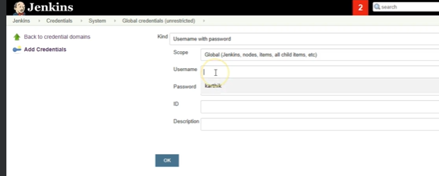

### Checkout OS and execute script:

* Used to run script in both OS windows and linux.
* isunix() function is used. It will be true if underline os is linux and false if not.

### Trim:

* Used to cut the string.
* We can use negative indices.
* We use range operator(..) in trim function.

### Sample Pipeline Script:

pipeline {

agent any

// global environment variable

environment{

TOOLNAME="Jenkins"

NAME1 = "pravin"

NAME2 = "komal"

}

/*triggers{

cron('H/30 * * * *')

pollSCM('H/30 * * * *')

}*/

//parameters are interactive variables used to get user input before build

parameters{

choice(name: 'dryrun', choices: "Yes\nNo\n", description: "Select Yes for first build")

string(name: 'TOOL', defaultValue: 'Jenkins', description:'This is sample description')

choice(name: 'STAGE', choices: "Build\nTest\nDeploy", description: "Select any of given choices")

booleanParam(name: 'SONAR', defaultValue: 'true', description: 'Toogle to bypass build')

password(name: 'PASSWORD', defaultValue: 'SECRET', description: 'Enter a passowrd')

file(name: 'FILE', description: "Choose file")

}

/*options{

retry(3)

timeout(time: 10, unit: 'SECONDS')

timestamps()

disableConcurrentBuilds()

buildDiscarder logRotator(artifactDaysToKeepStr: '', artifactNumToKeepStr: '', daysToKeepStr: '', numToKeepStr: '5')

}*/

stages{

// dryrun stage added so that first failed build will be displayed

stage('Parameterizing'){

steps{

script{

if("${params.dryrun}" == "Yes"){

echo 'dryrun stage'

currentBuild.result='ABORTED'

error('Dry RUN COMPLETED. JOB PARAMETERIZED.')

}

}

}

}

stage('Tool') {

//stage level environemnt variable

environment{

TOOLNAME="Docker"

}

steps{

//script level variable

sh 'sleep 15'

script{

TOOLNAME = "Kubernetes"

NAME = NAME1 + " " + NAME2

echo "Welcome $NAME in jenkins"

}

//parameters can be accessed using parameter name or using param keyword

echo "$TOOL and ${params.TOOL} is same"

}

}

stage('Choice'){

steps {

echo "My choice is $STAGE"

}

}

stage('Test'){

steps{

/* conditional statements can be

used only inside script directive.

params keyword used inside script directive to access parameters */

script{

if(params.TOOL == "Jenkins"){

echo "This is test stage"

}

}

}

}

stage('SONAR'){

steps {

script{

if(params.SONAR){

echo "Soanar steps will be executed"

}

}

}

}

}

}

### Link for Pipeline syntax Documents:

https://www.jenkins.io/doc/book/pipeline/syntax/#:~:text=A%20text%20parameter%2C%20which%20can,'%2C%20description%3A%20'')%20%7D%20.&text=A%20boolean%20parameter%2C%20for%20example,true%2C%20description%3A%20'')%20%7D%20.

## Various Type of Jobs in Jenkins:

### Executing Shell commands or shell script:

* It can be implemented with freestyle Job.
* Create a free style Job.
* In build steps use execute shell option and write down the script or path of scrip to run it.
* If shell script or commands required to be feed with parameters then we can use “This project is parameterized option”. User can assign default values to parameters or can give choice of values to parameters.
* Boolean parameters used for conditions that can be used inside script.
* **Parameters are interactive variable whose value can be feed during build.**

### Mysql Back up on AWS S3 bucket:

* Add db_host service with MySQL image to docker-copose file and Create a MySQL container with using docker-compose file.
* Create MySQL client and aws cli client on remote host using docker file. To create it modify dockerfile as follows.
* Add instruction to install aws cli and MYSQL client.

**FROM centos**

**RUN cd /etc/yum.repos.d/ && \**

**sed -i 's/mirrorlist/#mirrorlist/g' /etc/yum.repos.d/CentOS-* && \**

**sed -i 's|#baseurl=http://mirror.centos.org|baseurl=http://vault.centos.org|g' /etc/yum.repos.d/CentOS-* && \**

**yum update -y**

**RUN yum install -y openssh-server**

**RUN useradd remote_user && \**

**echo "remote_user:1234" | chpasswd && \**

**mkdir /home/remote_user/.ssh && \**

**chmod 700 /home/remote_user/.ssh**

**COPY remote-key.pub /home/remote_user/.ssh/authorized_keys**

**RUN chown remote_user:remote_user -R /home/remote_user/.ssh && \**

**chmod 600 /home/remote_user/.ssh/authorized_keys**

**RUN ssh-keygen -A**

**RUN rm /run/nologin**

**RUN yum install msqql**

**RUM yum install python3**

**RUN**

**CMD /usr/sbin/sshd –D**

* Login to remote-host container, connect to mysql container using mysql client and Create a database and feed database with some entries in db container hosting mysql.

**mysql -h db_host -u root -p**

it will prompt for password. Enter password and connect.

**create databsea testinfo;**

**create table info (name varchar(50), lastname varchar(50), age int(3));**

**desc info;**

**insert into info values ('pravin', 'yadav', 24)**

* Login to remote-host container. remote-host container connects with db container and save the back on local container. Command has details of db-host and username and passwords.

**docker exec -it remote-host bash**

**mysqldump -h db_host -u root -p 1234 testdb > /tmp/db.sql**

## Deploying Java Helm charts in EKS cluster using Jenkin pipelines:

## How to streamline the Development and CI:

1. Safeguard the changes going into git because:
   1. Build should never breakdown on Main Line.
   2. Fixing issue on main line is costly
2. Define the development workflow. Trunk based development.
3. Ensure branch policies
   1. Nobody checks directly into main line
   2. Every developer/feature has a branch
   3. All changes must be pulled via merge requests.
4. Set per branch pipeline using jenkins
5. Set Code review policies
6. Setup project gating system using sonarcube.

In Jenkins configuration following are important categories:

1. System Configuration:
   1. Number of Executors: Defines number of jobs that can be run in parallel. Ideal value is equal to number of cores of cpu. E.g. for octa core CPU value is 8.
2. Security Configuration: Enable by default.
   1. Authorization:
   2. Authentication: One can configure project based authorization or metric based authorization etc.
3. Global Tools: We can add tools that is to be integrated with Jenkins using this option.
   1. Maven:
   2. NodeJS:
   3. JDK:
   4. Git:
   5. Docker:
4. Plugins:
   1. Available:
   2. Installed
   3. Updates

Type of jobs Jenkins supports by default are:

* Free Style: Used if user don’t know which plugins to use and other info
* Maven: used for Java maven based project
* Pipeline
* Multi Branch Pipeline
* Folder

Note: Based on plugins installed jenkin can support other than default job types.

Jenkin Job configuration page consist of following sections:

* General: Job description is added here
* SCM: define the source of code for Jenkins.
* Build Triggers: Define how and when job is triggered
* Build ENV: Required build environment variables and other specifications etc. is defined in this section.
* Build: We add the steps to build the configuration.
* Post Build: Actions after build is completed such as triggering a new job or sending a email or some other action is defined here.

Building Pipeline for application:

In an example we are building pipeline for maven app.

Steps to build Maven app are  
1) Build app: mvn compile

2) Test App: mvn clean test

3) Package App: mvn package -DskipTests

Project can be built directly using maven plugin or by defining code in pipeline object.

Steps by using maven plugin:

1. Create Maven Job.
2. In maven job add git repository URL and credentials.
3. Configure MAVEN toll in global tool configuration and copy the name assigned to it.
4. In build section specify the maven tool name (copied above), mentioned pom.xml against Root POM and mention compile for goals and options.
5. Save the configuration and try to build app.
6. You can click on progress bar to view console output.

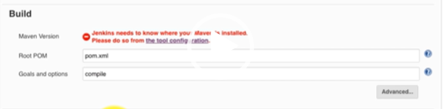

1. Now we need to add test and package jobs.
2. These jobs similar to build job only difference in goal and options section. So create new job and use copy from option get build job copied and modify it as per requirement.
3. For test job mention clean test in goals and option section.
4. For test job mention package -DskipTests in goals and option section. Note down the path of war file it should be Target subdirectory of project path.
5. In post build action select the option Archive the artifact and mentioned path of the archive directory using regular expression so that required file is archived.
6. Connect the above three job using upstream and downstream configurations.

* Downstream is defined using post build actions: use build other projects option of post build actions.

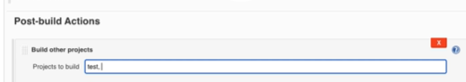

* Upstream is defined using build triggers: From build trigger option use” Build after other projects are build” sub-option and mention the job name that is to completed before this job build triggered.

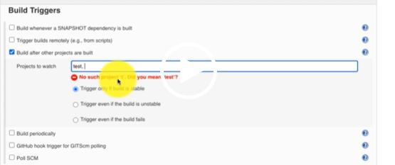

* To visualize the above pipeline graphically user need to install Build Pipeline plugin.
* On project page click on + symbol to get option of build pipeline view.
* Everything is set and we need to change only one parameter i.e. No Of Displayed Builds to 5.

Setting Up automated trigger:

* Webhook Option: Git webhook hub initiate trigger to build in Jenkins if there is any change in git hub repository. But this option is useful if you host Jenkins publicly.
* Pooling option: With this option jenkins polls the changes from git and if there is change it will trigger a job. We need to define interval at which Jenkins will attempt to poll from changes.
* Build periodically: It has option similar to cron job. We can set interval at which jenkins will build the job.

# Jenkins Project On Kodekloude:

Our application development team has recently finished the MVP development for one of the applications and it's ready to be deployed on production.  
  
The go-app repository on the Gitea server contains the source code of this application. The dev branch of this repository is used for testing, hence we want to deploy it on the dev environment and the master branch should be deployed on the production environment.  
  
On dev server /opt/go-app is the document root of the application and we have already setup the dev branch over there for your convenience. In your build step, you will just need to pull the latest dev branch code from the repository using git pull command. You can access the dev server using below given credentials:  
  
Host: gotest-dev01  
  
User: bob  
  
Password: caleston123  
Similarly on production server /opt/go-app is the document root of the application and we have already setup the master branch over there for your convenience. In your build step, you will just need to pull the latest master branch code from the repository using git pull command. You can access the production server using below given credentials:  
  
  
Host: gotest-prod01  
  
User: bob  
  
Password: caleston123  
  
  
Create a pipeline job in Jenkins, and configure it as per details mentioned below:

Prerequisites:  
  
-> Install the required plugins which are needed for adding SSH agent nodes and for creating pipeline jobs.  
  
-> Add dev and production servers as SSH node agents in Jenkins.  
  
-> You can use /opt as the Remote root directory for both of these nodes to avoid any permission issues.  
  
-> To make nodes work, you will also need to add the respective credentials in Jenkins for these servers.  
  
  
Job configuration:  
  
-> The job name should be go-app-deployment  
  
-> It must be a pipeline job.  
  
-> The first stage here should be to build the dev branch code which must be deployed on the dev server/environment, you can name the stage as per your choice. As we have already setup the repo/branch on the server so you will just need to run the git pull command.  
  
Here is a hint, how you can make it run on the dev server. To do so, add an agent configuration in each of your stages like this:

stage('Build Dev') {

agent {

label {

label 'dev'

customWorkspace "/opt/go-app"

}

}

steps {

sh 'git pull'

}

}

Please note that label 'dev' is the label you will give to your node (so update it accordingly) and you will need to set customWorkspace "/opt/go-app" (its same for both of the servers/environments) to make it work on this setup/back-end.  
  
  
-> The second stage should be to run some unit tests (again you can name the stage as per your choice). You can execute the tests using a stage like:

stage('Test Dev') {

agent {

label {

label 'dev'

customWorkspace "/opt/go-app"

}

}

steps {

sh 'go test ./...'

}

}

-> The last stage for dev would be to deploy the application. You can use a stage like:

stage('Deploy Dev') {

agent {

label {

label 'dev'

customWorkspace "/opt/go-app"

}

}

steps {

script {

withEnv ( ['JENKINS_NODE_COOKIE=do_not_kill'] ) {

sh 'go run main.go &'

}

}

}

}

You must have noticed an extra parameter in this stage i.e withEnv ( ['JENKINS_NODE_COOKIE=do_not_kill'] ), it is needed to make sure Jenkins doesn't kill the background process we are starting in this stage on the respective server.  
  
  
-> Similarly configure the same stages (with different name and prod specific values) for the production deployment. So the pipeline will have total 6 stages (three for each environment).  
  
-> Make sure to build the job at least once and make sure its building successfully.

-

**Check**

-

**Next**

Run the pipeline job.

Check job configuration and output.

Test Dev app.

Test Prod app.

***Solution:***

Login into the Jenkins server and follow the below given steps:  
  
Install Plugins:  
  
**1.** Go to Manage Jenkins.  
**2.** Click on Plugins.  
**3.** Under Available, search for SSH Build Agents plugin and select it.  
**4.** Now search for Pipeline plugin and select it.  
**5.** Now install these plugins.  
**6.** Once installed click on Restart Jenkins when installation is complete and no jobs are running.  
  
Add Credentials:  
**1.** Go to Manage Jenkins.  
**2.** Click on Credentials.  
**3.** Click on (global) under Domains.  
**4.** From the option on the right side, click on Add Credentials.  
**5.** Enter bob under Username.  
**6.** Enter caleston123 under Password.  
**7.** Leave other options as it is and click on OK.

Add Nodes:  
**1.** Go to Manage Jenkins.  
**2.** Click on Nodes and Clouds.  
**3.** From the option available on the right side, click on New Node.  
  
**4.** Enter the Node name i.e dev.  
  
**5.** Enable Permanent Agent option and click on OK.  
  
**6.** Enter /opt under Remote root directory.  
  
**7.** Enter dev under Labels.  
  
**8.** Select Launch Agents via SSH under Launch method.  
  
**9.** Enter gotest-dev01 under Host and select the credentials you created.  
  
**10.** Under Host Key Verification Strategy, select Non verifying verification strategy.  
  
**11.** Leave all other options as it is and click on Save  
  
**12.** Click on the dev node and there shouldn't be any errors.  
  
**13.** Just in case the dev node is in error state, then try to relaunch it.  
  
**14.** Follow same steps for adding prod node, just take care about the node name, label and host.  
  
Create and Configure the job:  
  
**1.** On the left of the Jenkins dashboard, click on New Item.  
  
**2.** Enter the job name go-app-deployment.  
  
**3.** Select Pipeline job and click on OK.  
  
**4.** Under Pipeline section keep selected Pipeline script as Definition and add below given code in the Script

pipeline {

agent none

stages {

//DEV

**stage**('Build Dev') {

agent {

label {

label 'dev'

customWorkspace "/opt/go-app"

}

}

steps {

sh 'git pull'

}

}

**stage**('Test Dev') {

agent {

label {

label 'dev'

customWorkspace "/opt/go-app"

}

}

steps {

sh 'go test ./...'

}

}

**stage**('Deploy Dev') {

agent {

label {

label 'dev'

customWorkspace "/opt/go-app"

}

}

steps {

script {

withEnv ( ['JENKINS_NODE_COOKIE=do_not_kill'] ) {

sh 'go run main.go &'

}

}

}

}

//PROD

**stage**('Build Prod') {

agent {

label {

label 'prod'

customWorkspace "/opt/go-app"

}

}

steps {

sh 'git pull'

}

}

**stage**('Test Prod') {

agent {

label {

label 'prod'

customWorkspace "/opt/go-app"

}

}

steps {

sh 'go test ./...'

}

}

**stage**('Deploy Prod') {

agent {

label {

label 'prod'

customWorkspace "/opt/go-app"

}

}

steps {

script {

withEnv ( ['JENKINS_NODE_COOKIE=do_not_kill'] ) {

sh 'go run main.go &'

}

}

}

}

}

}

**5.** Finally save the job and build.

Ref for following Jenkins script

<https://github.com/kodekloudhub/kubernetes-devops-security>

<https://github.com/kodekloudhub/devsecops>

# Jenkins Pipeline Full Script with Security Scanning.

@Library('slack') _

/////// ******************************* Code for fectching Failed Stage Name ******************************* ///////

import io.jenkins.blueocean.rest.impl.pipeline.PipelineNodeGraphVisitor

import io.jenkins.blueocean.rest.impl.pipeline.FlowNodeWrapper

import org.jenkinsci.plugins.workflow.support.steps.build.RunWrapper

import org.jenkinsci.plugins.workflow.actions.ErrorAction

// Get information about all stages, including the failure cases

// Returns a list of maps: [[id, failedStageName, result, errors]]

@NonCPS

List<Map> getStageResults( RunWrapper build ) {

// Get all pipeline nodes that represent stages

def visitor = new PipelineNodeGraphVisitor( build.rawBuild )

def stages = visitor.pipelineNodes.findAll{ it.type == FlowNodeWrapper.NodeType.STAGE }

return stages.collect{ stage ->

// Get all the errors from the stage

def errorActions = stage.getPipelineActions( ErrorAction )

def errors = errorActions?.collect{ it.error }.unique()

return [

id: stage.id,

failedStageName: stage.displayName,

result: "${stage.status.result}",

errors: errors

]

}

}

// Get information of all failed stages

@NonCPS

List<Map> getFailedStages( RunWrapper build ) {

return getStageResults( build ).findAll{ it.result == 'FAILURE' }

}

/////// ******************************* Code for fectching Failed Stage Name ******************************* ///////

pipeline {

agent any

environment {

deploymentName = "devsecops"

containerName = "devsecops-container"

serviceName = "devsecops-svc"

imageName = "siddharth67/numeric-app:${GIT_COMMIT}"

applicationURL="http://devsecops-demo.eastus.cloudapp.azure.com"

applicationURI="/increment/99"

}

stages {

// stage('Build Artifact - Maven') {

// steps {

// sh "mvn clean package -DskipTests=true"

// archive 'target/*.jar'

// }

// }

// stage('Unit Tests - JUnit and JaCoCo') {

// steps {

// sh "mvn test"

// }

// }

// stage('Mutation Tests - PIT') {

// steps {

// sh "mvn org.pitest:pitest-maven:mutationCoverage"

// }

// }

// stage('SonarQube - SAST') {

// steps {

// withSonarQubeEnv('SonarQube') {

// sh "mvn sonar:sonar \

// -Dsonar.projectKey=numeric-application \

// -Dsonar.host.url=http://devsecops-demo.eastus.cloudapp.azure.com:9000"

// }

// timeout(time: 2, unit: 'MINUTES') {

// script {

// waitForQualityGate abortPipeline: true

// }

// }

// }

// }

// stage('Vulnerability Scan - Docker') {

// steps {

// parallel(

// "Dependency Scan": {

// sh "mvn dependency-check:check"

// },

// "Trivy Scan":{

// sh "bash trivy-docker-image-scan.sh"

// },

// "OPA Conftest":{

// sh 'docker run --rm -v $(pwd):/project openpolicyagent/conftest test --policy opa-docker-security.rego Dockerfile'

// }

// )

// }

// }

// stage('Docker Build and Push') {

// steps {

// withDockerRegistry([credentialsId: "docker-hub", url: ""]) {

// sh 'printenv'

// sh 'sudo docker build -t siddharth67/numeric-app:""$GIT_COMMIT"" .'

// sh 'docker push siddharth67/numeric-app:""$GIT_COMMIT""'

// }

// }

// }

// stage('Vulnerability Scan - Kubernetes') {

// steps {

// parallel(

// "OPA Scan": {

// sh 'docker run --rm -v $(pwd):/project openpolicyagent/conftest test --policy opa-k8s-security.rego k8s_deployment_service.yaml'

// },

// "Kubesec Scan": {

// sh "bash kubesec-scan.sh"

// },

// "Trivy Scan": {

// sh "bash trivy-k8s-scan.sh"

// }

// )

// }

// }

// stage('K8S Deployment - DEV') {

// steps {

// parallel(

// "Deployment": {

// withKubeConfig([credentialsId: 'kubeconfig']) {

// sh "bash k8s-deployment.sh"

// }

// },

// "Rollout Status": {

// withKubeConfig([credentialsId: 'kubeconfig']) {

// sh "bash k8s-deployment-rollout-status.sh"

// }

// }

// )

// }

// }

// stage('Integration Tests - DEV') {

// steps {

// script {

// try {

// withKubeConfig([credentialsId: 'kubeconfig']) {

// sh "bash integration-test.sh"

// }

// } catch (e) {

// withKubeConfig([credentialsId: 'kubeconfig']) {

// sh "kubectl -n default rollout undo deploy ${deploymentName}"

// }

// throw e

// }

// }

// }

// }

// stage('OWASP ZAP - DAST') {

// steps {

// withKubeConfig([credentialsId: 'kubeconfig']) {

// sh 'bash zap.sh'

// }

// }

// }

// stage('Prompte to PROD?') {

// steps {

// timeout(time: 2, unit: 'DAYS') {

// input 'Do you want to Approve the Deployment to Production Environment/Namespace?'

// }

// }

// }

// stage('K8S CIS Benchmark') {

// steps {

// script {

// parallel(

// "Master": {

// sh "bash cis-master.sh"

// },

// "Etcd": {

// sh "bash cis-etcd.sh"

// },

// "Kubelet": {

// sh "bash cis-kubelet.sh"

// }

// )

// }

// }

// }

// stage('K8S Deployment - PROD') {

// steps {

// parallel(

// "Deployment": {

// withKubeConfig([credentialsId: 'kubeconfig']) {

// sh "sed -i 's#replace#${imageName}#g' k8s_PROD-deployment_service.yaml"

// sh "kubectl -n prod apply -f k8s_PROD-deployment_service.yaml"

// }

// },

// "Rollout Status": {

// withKubeConfig([credentialsId: 'kubeconfig']) {

// sh "bash k8s-PROD-deployment-rollout-status.sh"

// }

// }

// )

// }

// }

// stage('Integration Tests - PROD') {

// steps {

// script {

// try {

// withKubeConfig([credentialsId: 'kubeconfig']) {

// sh "bash integration-test-PROD.sh"

// }

// } catch (e) {

// withKubeConfig([credentialsId: 'kubeconfig']) {

// sh "kubectl -n prod rollout undo deploy ${deploymentName}"

// }

// throw e

// }

// }

// }

// }

stage('Testing Slack - 1') {

steps {

sh 'exit 0'

}

}

stage('Testing Slack - Error Stage') {

steps {

sh 'exit 0'

}

}

}

post {

// always {

// junit 'target/surefire-reports/*.xml'

// jacoco execPattern: 'target/jacoco.exec'

// pitmutation mutationStatsFile: '**/target/pit-reports/**/mutations.xml'

// dependencyCheckPublisher pattern: 'target/dependency-check-report.xml'

// publishHTML([allowMissing: false, alwaysLinkToLastBuild: true, keepAll: true, reportDir: 'owasp-zap-report', reportFiles: 'zap_report.html', reportName: 'OWASP ZAP HTML Report', reportTitles: 'OWASP ZAP HTML Report'])

// //Use sendNotifications.groovy from shared library and provide current build result as parameter

// //sendNotification currentBuild.result

// }

success {

script {

/* Use slackNotifier.groovy from shared library and provide current build result as parameter */

env.failedStage = "none"

env.emoji = ":white_check_mark: :tada: :thumbsup_all:"

sendNotification currentBuild.result

}

}

failure {

script {

//Fetch information about failed stage

def failedStages = getFailedStages( currentBuild )

env.failedStage = failedStages.failedStageName

env.emoji = ":x: :red_circle: :sos:"

sendNotification currentBuild.result

}

}

}

}